Regional Haze Metrics Trends and HYSPLIT Trajectory Analyses

April 2017 DRAFT

Principal Contributors:
Tom Downs, CCM, ME DEP – Project manager
Martha Webster, ME DEP – Trajectory analyses and GIS mapping
Rich Greves, ME DEP – Speciation analyses

Table of Contents
Executive summary 3
1.0 Overview 4
2.0 Regional Haze Metrics Trends 5
3.0 Speciation Analysis 9
3.1 Comparison Plots of 2002, 2011 and 2015 Data 9
3.2 Percent Contribution Speciation Plots 14
4.0 Trajectory Analysis 19
4.1 Trajectory Analysis Results 19
4.1.1 Acadia National Park 20
4.1.2 Moosehorn Wilderness 24
4.1.3 Great Gulf Wilderness 27
4.1.4 Lye Brook Wilderness 31
4.1.5 Brigantine Wilderness 35
4.1.6 Shenandoah National Park 39
4.1.7 Dolly Sods Wilderness 43
4.1.8 James River Face Wilderness 46
5.0 Summary 50
References 51

Executive Summary

Staff from the Maine Department of Environmental Protection (MEDEP) carried out regional haze metrics and speciation analyses for 2000-2015 and trajectory modeling analyses for the “most impaired” visibility days in 2002, 2011 and 2015 for Class I areas in the Mid-Atlantic Northeast Visibility Union (MANE-VU) and nearby Class I areas in Virginia and West Virginia. For MANE-VU states, 2002 is the base year for the first round of regional haze State Implementation Plans (SIPs), 2011 is the base year for the current round of regional haze SIPs and 2015 is the latest year Interagency Monitoring of Protected Visual Environments (IMPROVE) data was available for this report.

Regional Haze metrics trends were completed for both the previously approved calculation method looking at “20% worst” visibility days and EPA proposed calculation method looking at the “20% most impaired” visibility days. Trends for both methods show that all Class I areas are well below the 2018 Uniform Rate of Progress (URP) level for the first SIP planning period and all but the Brigantine Wilderness Class I area are currently below the 2028 URP level for the second SIP planning period.

A speciation analysis divides light extinction impacts into the following principle components of regional haze: sulfates, nitrates, coarse mass, organic carbon mass, light absorbing carbon, soil, sea salt and Rayleigh scattering. For all Class I areas analyzed in this report, there is a significant decrease in sulfates from 2002 to 2011 with a further decrease from 2011 to 2015. This decrease resulted in a different mix of components and a different mix of days with more days in the winter for the 20% worst visibility days for some of the sites. Sulfates remain the dominant component of regional haze at all Class I areas; however the percentage contribution from sulfates in the current 5-year period (2011-15) has decreased 17-28% from the 2000-04 base year period. With more winter days the percent contribution from nitrates has increased at least 5% from the base year period at the Lye Brook Wilderness, Brigantine Wilderness, Shenandoah National Park and James River Face Wilderness Class I sites. The natural component of regional haze (Rayleigh scattering) percent contributions have also increased with Northern Class I areas increasing 9-13% and southern Class I areas increasing 6-9% from the base year period.

The HYbrid Single-Particle Lagrangian Integrated Trajectory (HYSPLIT) model was used to plot 72-hour back trajectories four times per day from a starting height of 500 meters above ground level. Results of the trajectory analyses can be used to identify transport patterns and can be used in conjunction with other MANE-VU contribution analysis tools (CALPUFF modeling and Q/d analyses) to determine states to be included in the consultation process. Results are in general agreement with CALPUFF modeling (MANE-VU 2016) results for states that may contribute to regional haze at MANE-VU Class I areas. There are strong transport patterns from Canadian source regions for Class I areas in Maine, New Hampshire and Vermont. Results also show that transport patterns have changed very little since the base year period as sulfates continue to dominate impacts at Class I areas.

1.0 Overview

For comparison purposes and to be consistent with the CALPUFF modeling analysis conducted by staff from New Hampshire Department of Environmental Services (NHDES) and Vermont Department of Environmental Conservation (VTDEC) (Mid-Atlantic Northeast Visibility Union April 2017), 2000-04 and 2011-15 regional haze daily speciation data and trajectories for the “20% most impaired” days in 2002, 2011 and 2015 were analyzed in this report for the following Class I areas (see Figure 1) that have historical IMPROVE monitoring sites in MANE-VU and nearby Class I areas in Virginia and West Virginia:
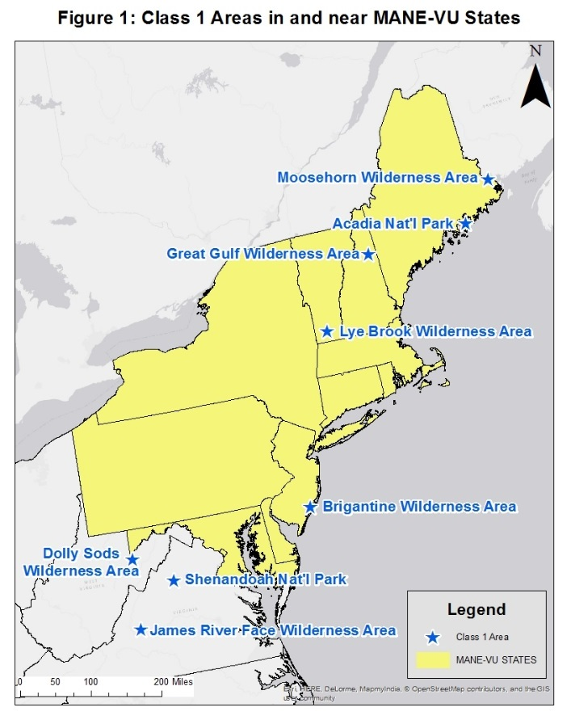
MANE-VU CLASS I AREAS
Acadia National Park, Maine
Moosehorn Wilderness Area, Maine (also representative of Roosevelt Campobello International Park, NB-ME)
Great Gulf Wilderness Area, New Hampshire (also representative of Presidential/Dry River Wilderness Area)
Lye Brook Wilderness Area, Vermont
Brigantine Wilderness Area, New Jersey

NEARBY CLASS I AREAS
Dolly Sods Wilderness Area, West Virginia (also representative of Otter Creek Wilderness Area)
Shenandoah National Park, Virginia
James River Face Wilderness Area, Virginia

2.0 Regional Haze Metrics Trends

EPA has not finalized the Regional Haze Guidance method to track changes in visibility for the “20% most impaired” days so analyses in this section will show trends of the proposed “new method” to calculate most impaired days and the “current method” to calculate 20% worst days. Both methods are the same for the 20% best day trends. Regional haze data from the following databases for 2000-2015 were downloaded from the Federal Land Manager Environmental Database (FED) (http://views.cira.colostate.edu/fed/ ) for all Class I areas listed in Section 1.0:
- IMPROVE AEROSOL, RHR II (New Equation) - current method metrics
- IMPROVE AEROSOL, RHR III (New Equation) - latest updated proposed new method metrics
- IMPROVE Natural Conditions II, Baseline (00-04) – current method metrics for natural conditions for the glide path
Derived natural conditions for the proposed new method metrics used to create the glide path are from Appendix E of EPA’s technical support document (US EPA July 2016) for EPA’s draft Regional Haze Guidance (US EPA 2016). New method metrics for the Lye Brook Class I areas are not yet available for the years 2012-15.

Regional Haze metrics trends were created for the 20% most impaired days, 20% worst days and 20% best days. Results are shown in Figures 2-9. All Class I areas show no visibility degradation for the 20% best days. All Class I areas have current (2011-2015 5-yr average) 20% worst days and 20% most impaired days visibility conditions below the respective 2028 level of the Uniform Rate of Progress (URP) with the exception of Lye Brook (due to no data available for the 20% most impaired days) and Brigantine Wilderness. For Brigantine, the 20% worst days visibility levels for 2012-15 are all below or near the 2028 URP level and the 20% most impaired visibility levels for 2012-15 are below or near the ‘proposed’ 2028 glide path level, so it’s expected that the trends at this site after 2016 data is available will also be below the respective 2028 glide path level.

Figure 2: Acadia National Park Haze Metrics Trends 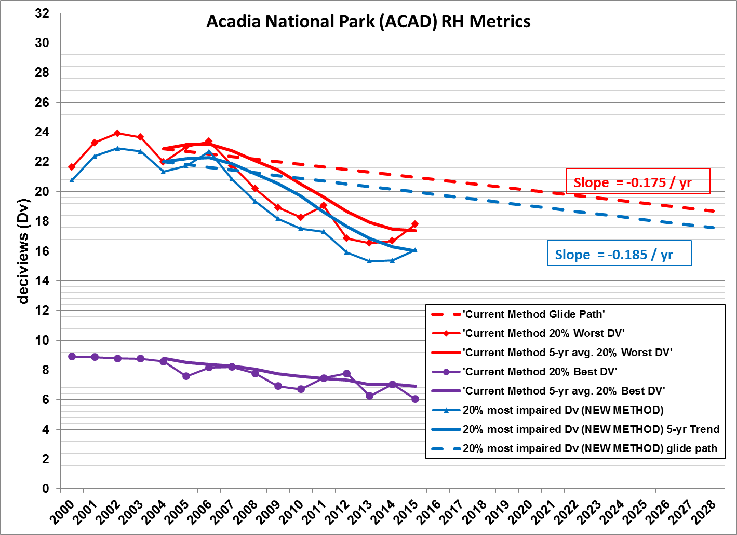
Figure 3: Moosehorn Wilderness Haze Metrics Trends 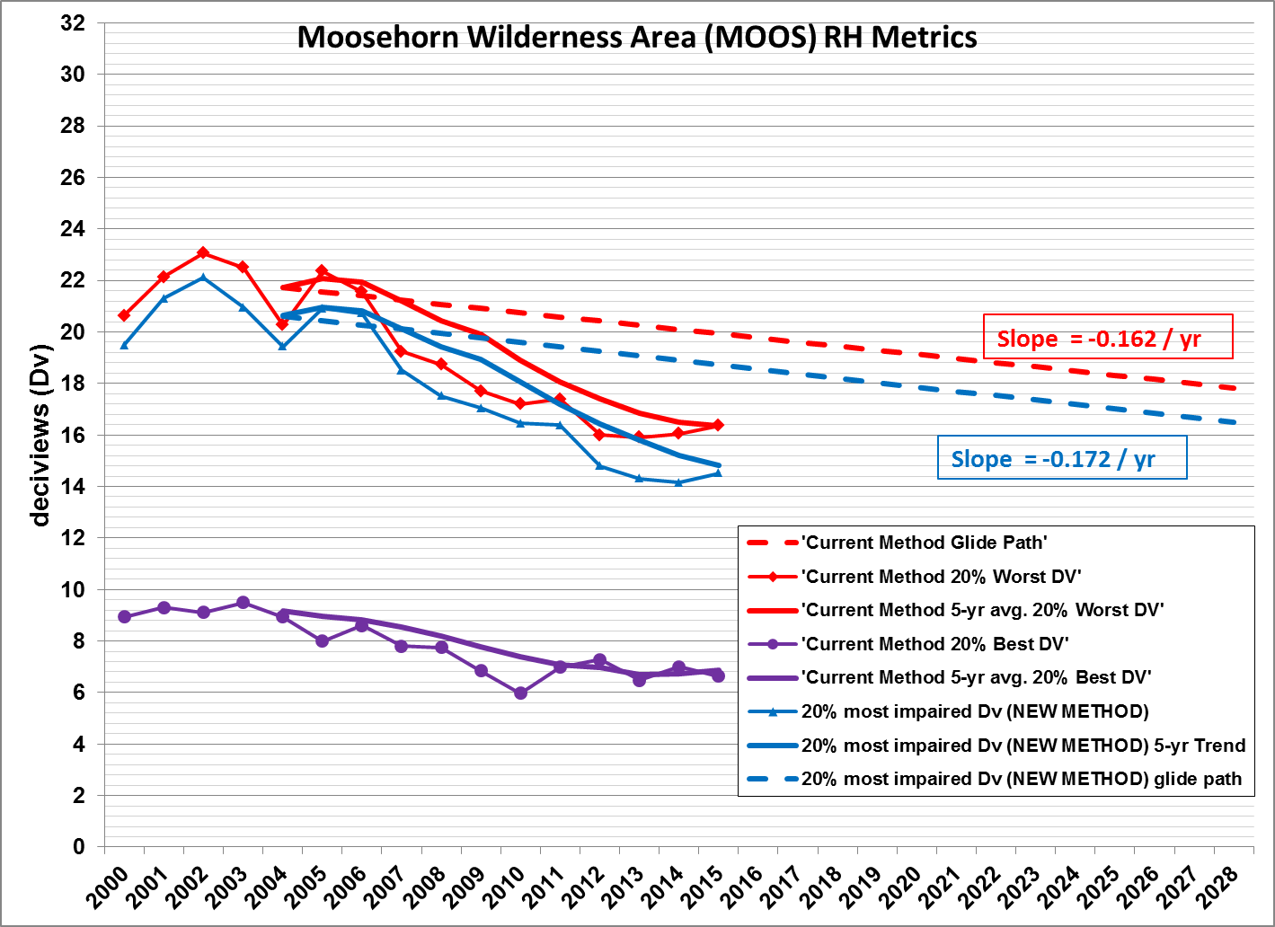
Figure 4: Great Gulf Wilderness Haze Metrics Trends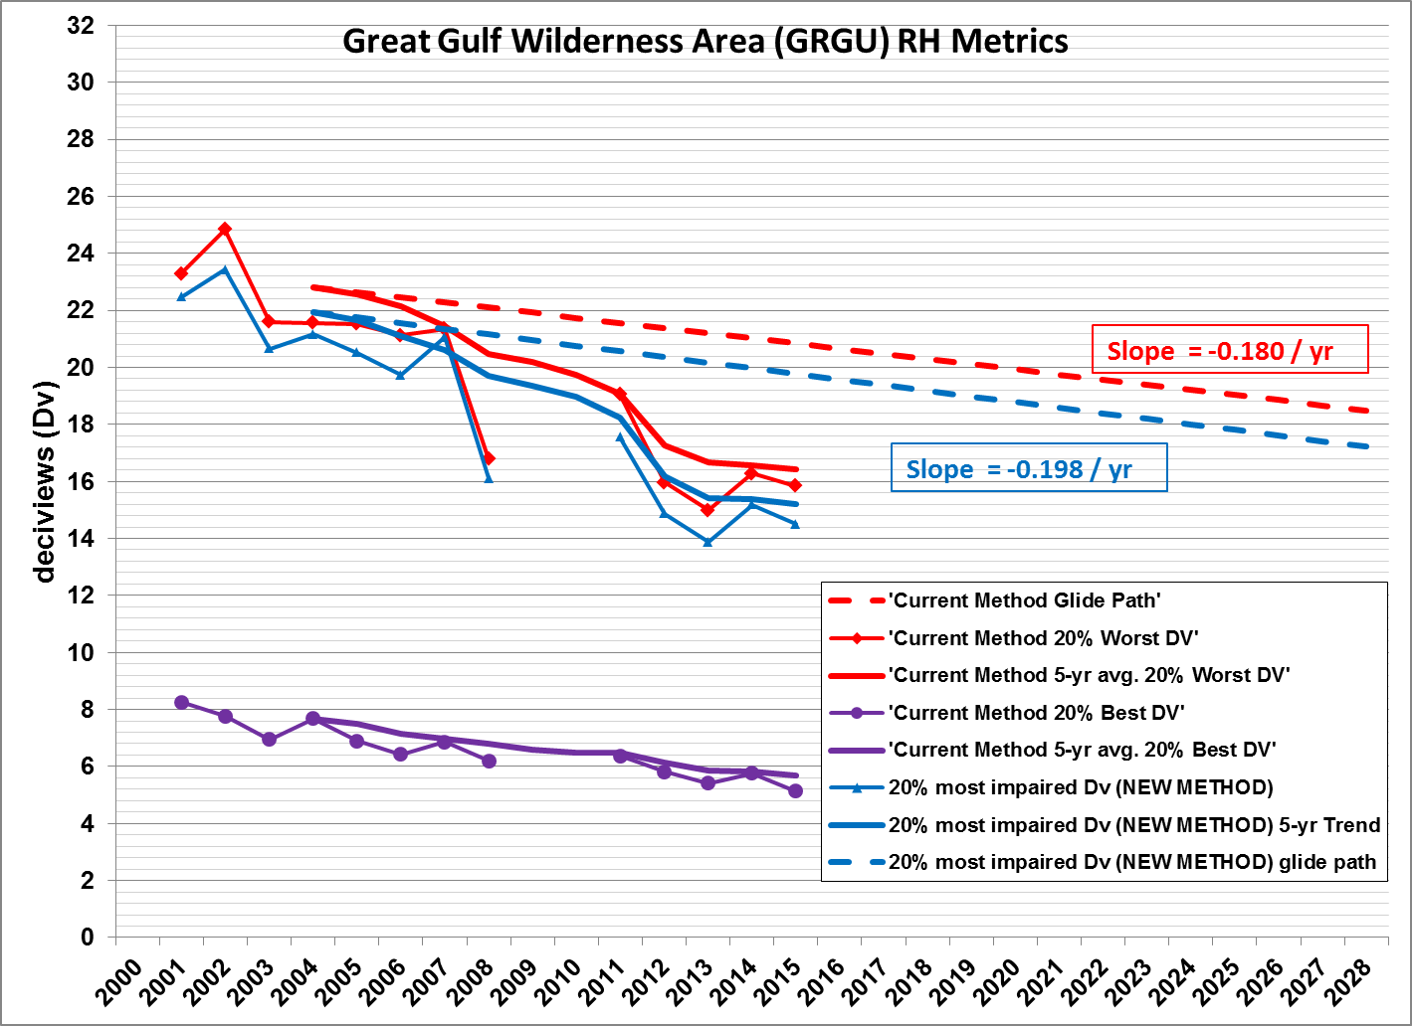
Figure 5: Lye Brook Wilderness Haze Metrics Trends 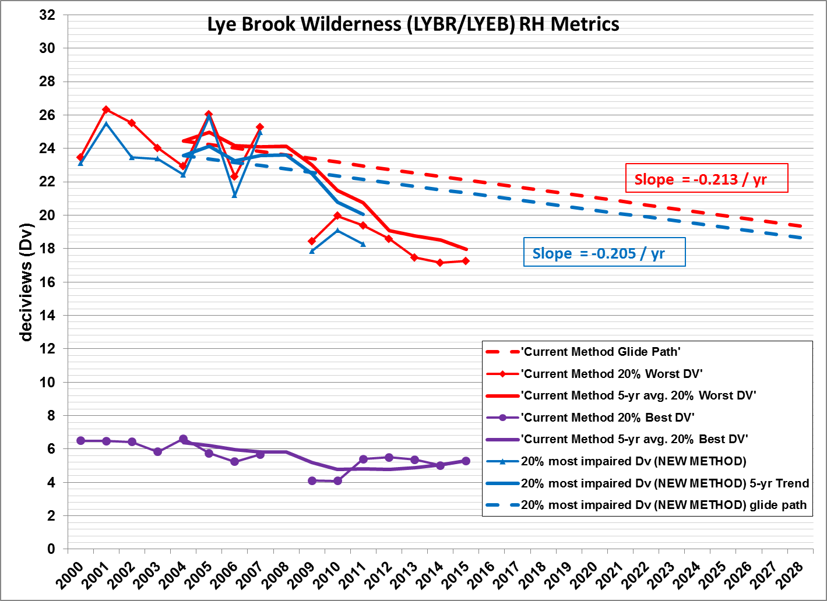
Figure 6: Brigantine Wilderness Haze Metrics Trends 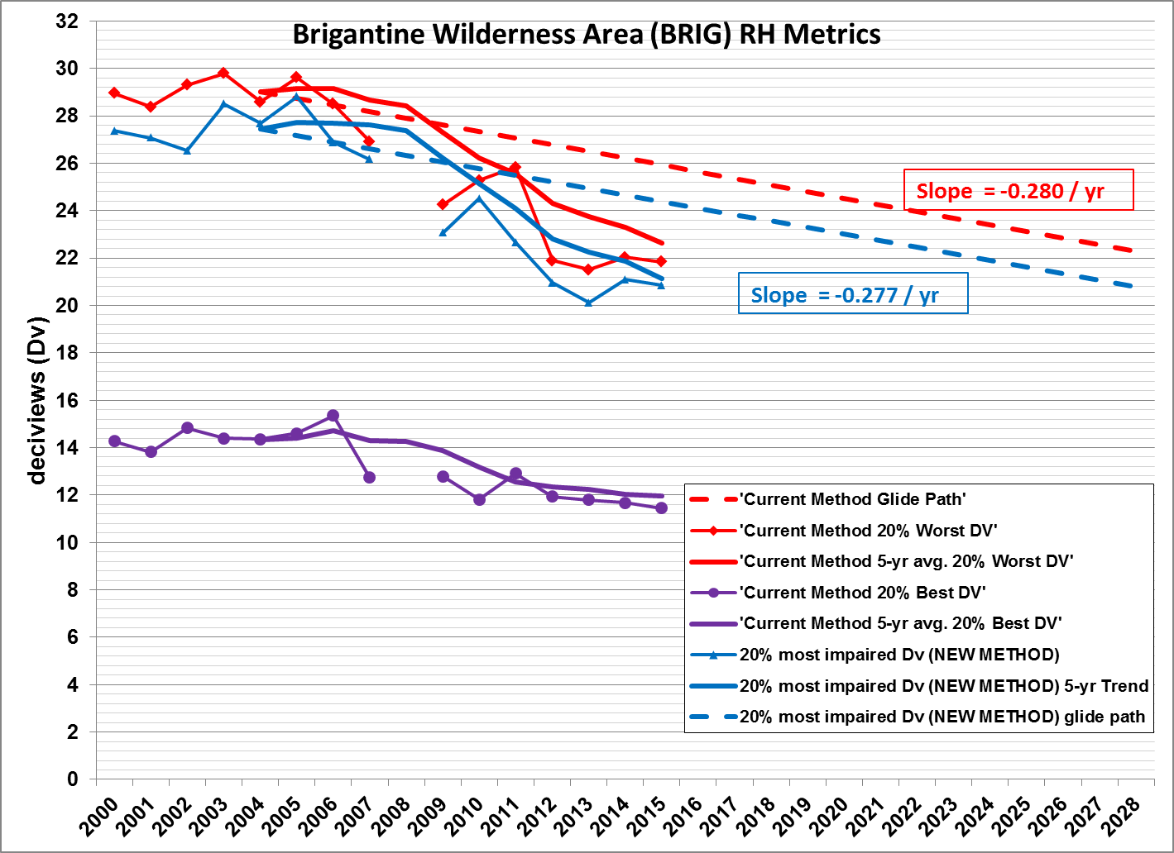
Figure 7: Shenandoah National Park Haze Metrics Trends 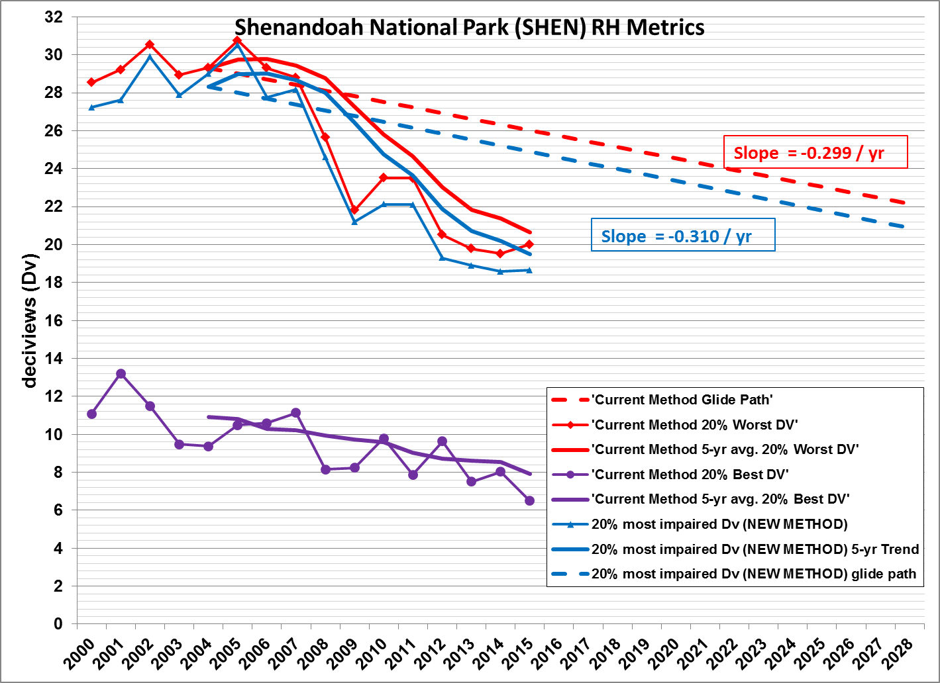
Figure 8: Dolly Sods Wilderness Haze Metrics Trends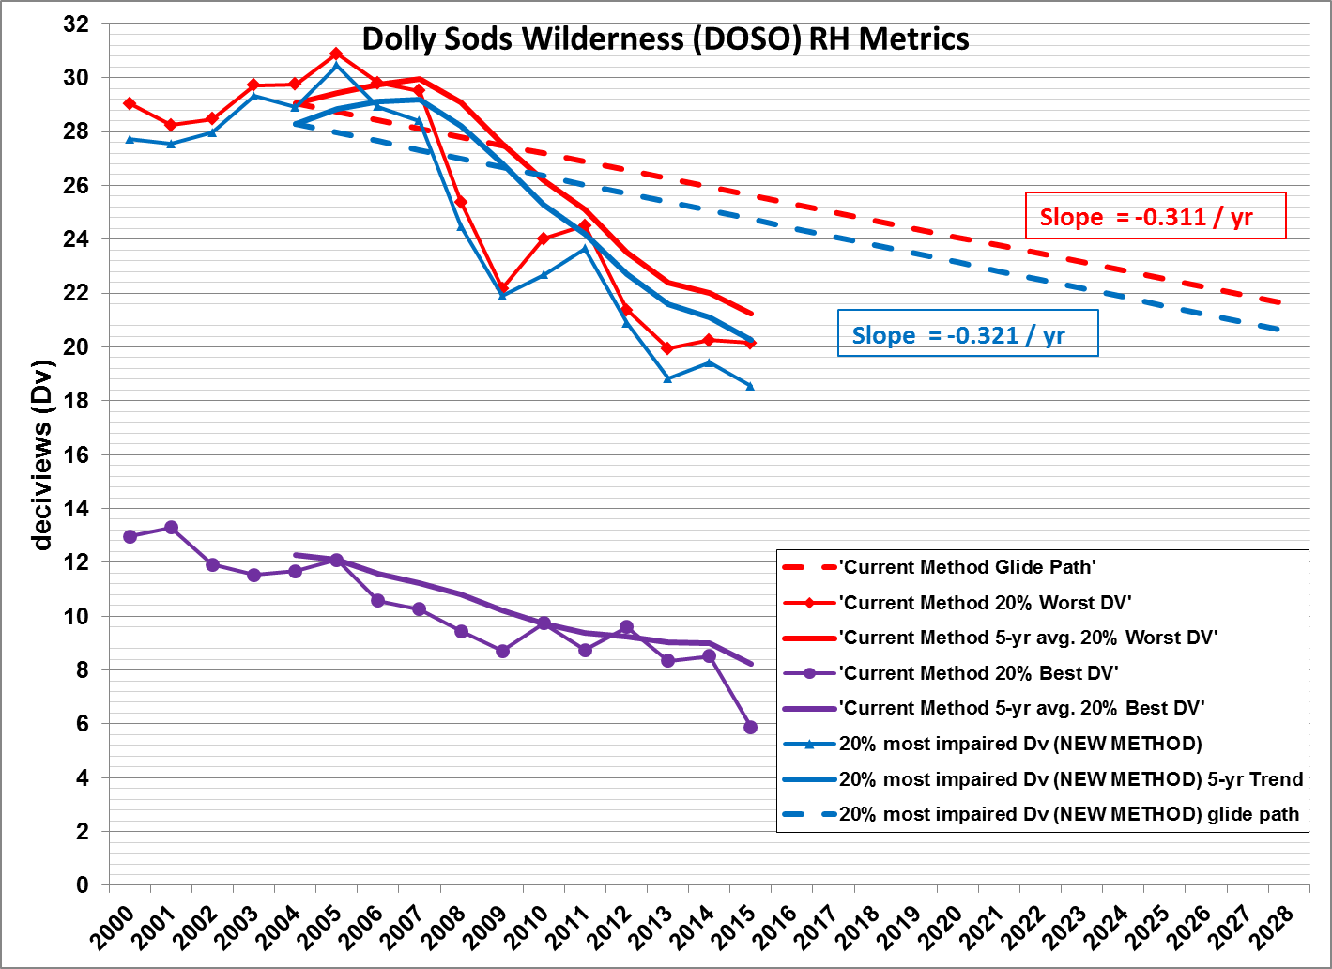
Figure 9: James River Face Wilderness Haze Metrics Trends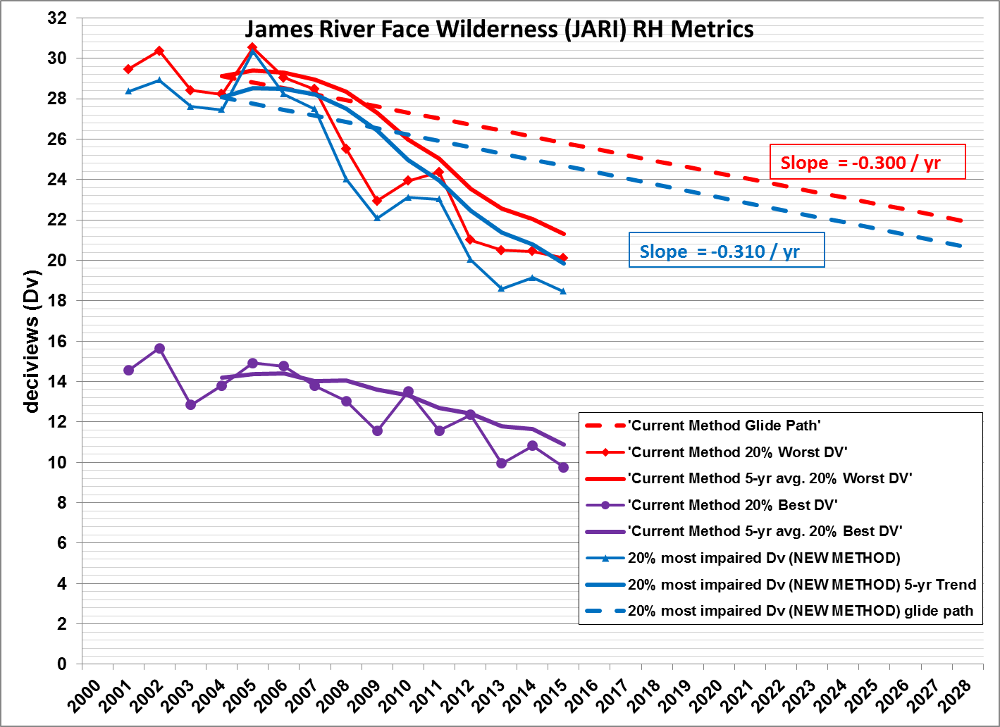

3.0 Speciation Analysis

Regional haze data (Improve Aerosol, RHR III (New Equation)) for 2000-2015 were downloaded from the FED for all Class I areas listed in Section 1.0. For the Lye Brook site RHR II data was used for 2012-15. The following light extinction (units of inverse megameters (Mm⁻¹) components of regional haze were analyzed in this report:

Sulfates
Nitrates
Organic Carbon Mass
Light Absorbing Carbon (Elemental Carbon)
Coarse Mass
Soil
Sea Salt
Rayleigh Scattering

3.1 Comparison Plots of 2002, 2011 and 2015 Data

For each Class I area plots (see Figures 10-17) were created showing light extinction speciation for each day for 2002, 2011 and 2015. For all Class I areas the trend clearly shows a significant decrease from 2002 to 2011 in light extinction especially for sulfates and a smaller decrease from 2011 to 2015.

Figure 10: Acadia National Park 2002/2011/2015 Speciation Comparison
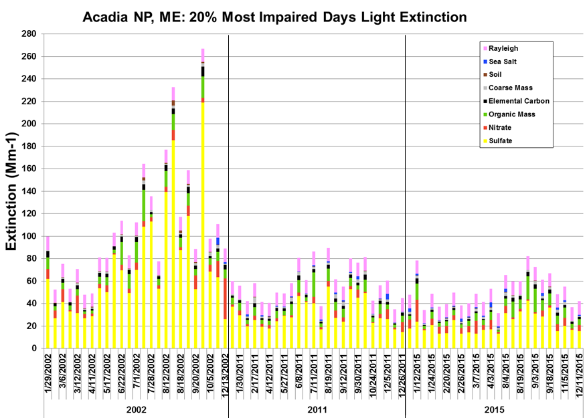

Figure 11: Moosehorn Wilderness 2002/2011/2015 Speciation Comparison 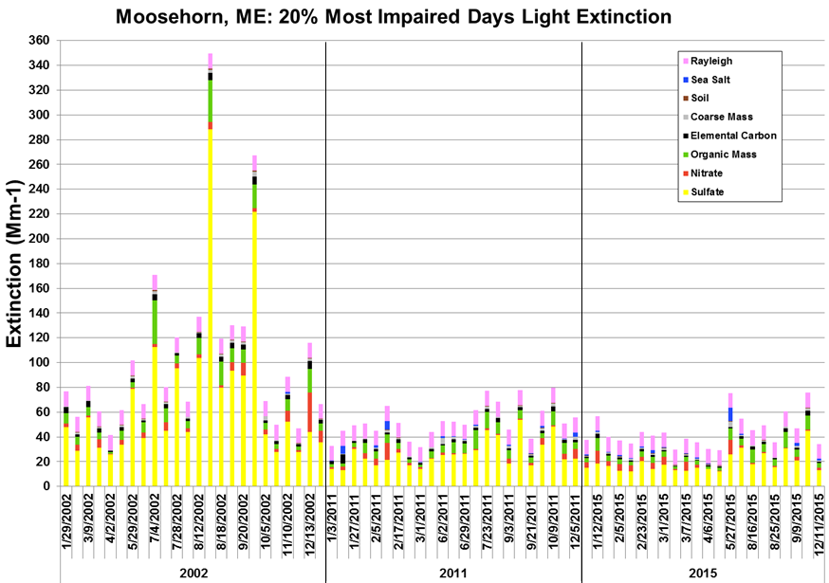
Figure 12: Great Gulf Wilderness 2002/2011/2015 Speciation Comparison 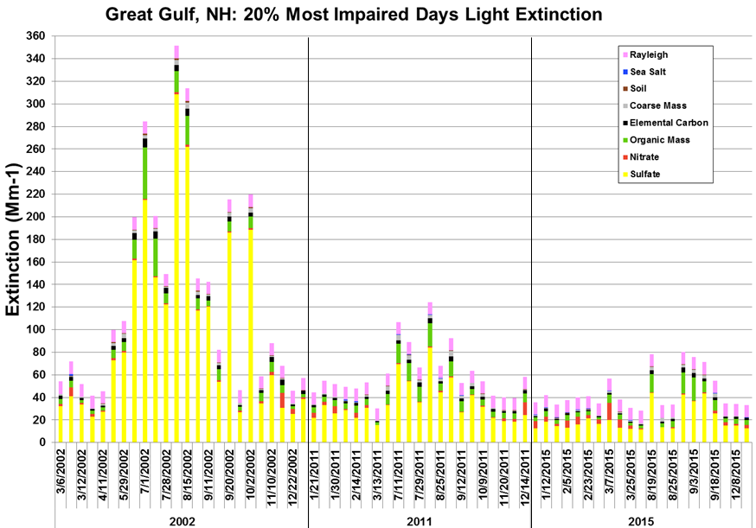
Figure 13: Lye Brook Wilderness 2011/2015 Speciation Comparison 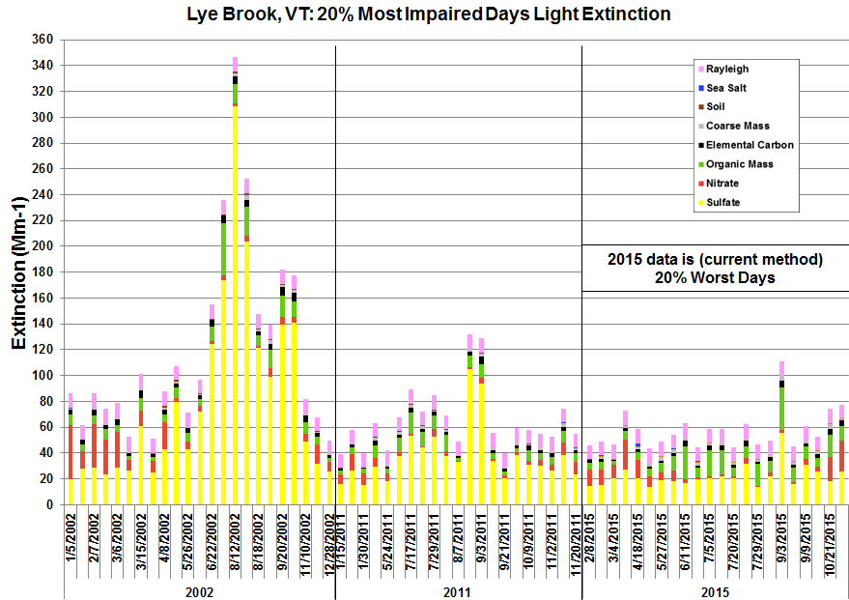

Figure 14: Brigantine Wilderness 2002/2011/2015 Speciation Comparison
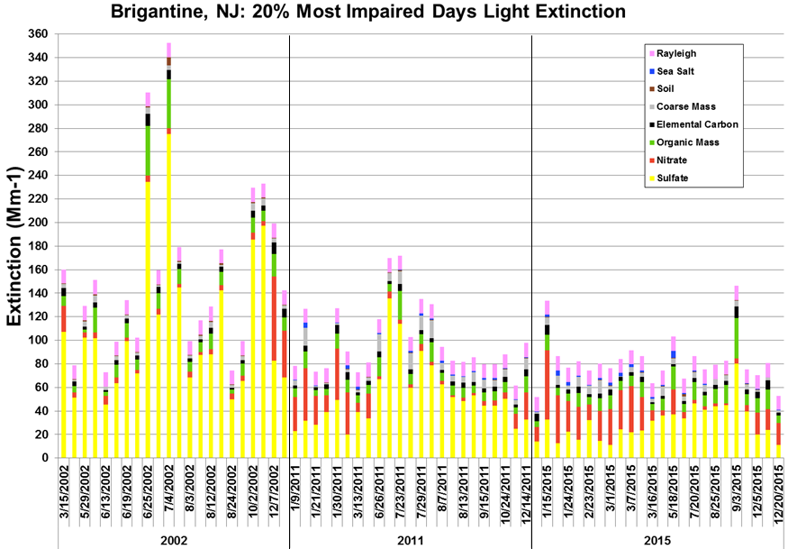
Figure 15: Shenandoah National Park 2002/2011/2015 Speciation Comparison
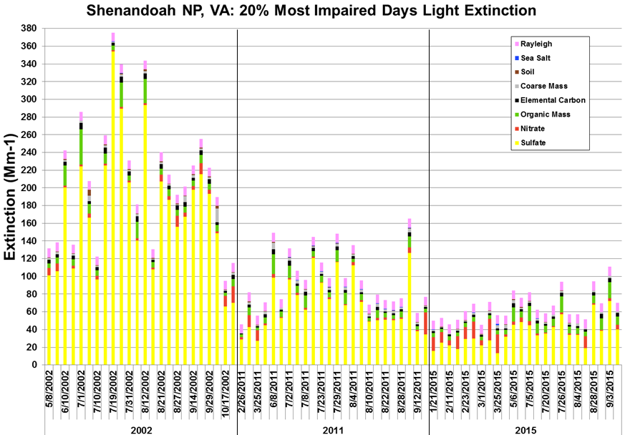
Figure 16: Dolly Sods Wilderness 2002/2011/2015 Speciation Comparison 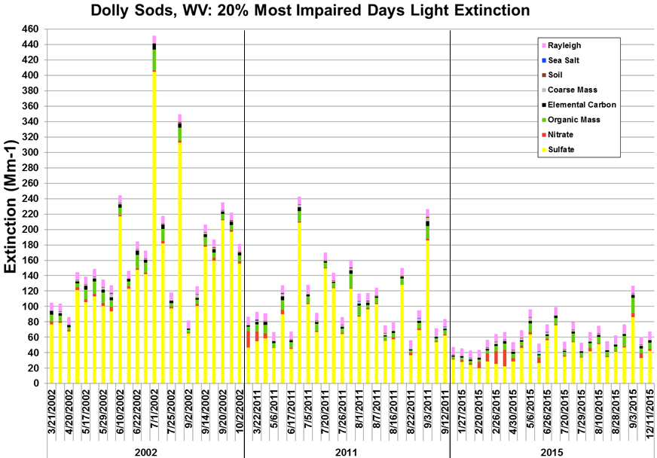

Figure 17: James River Face Wilderness 2002/2011/2015 Speciation Comparison
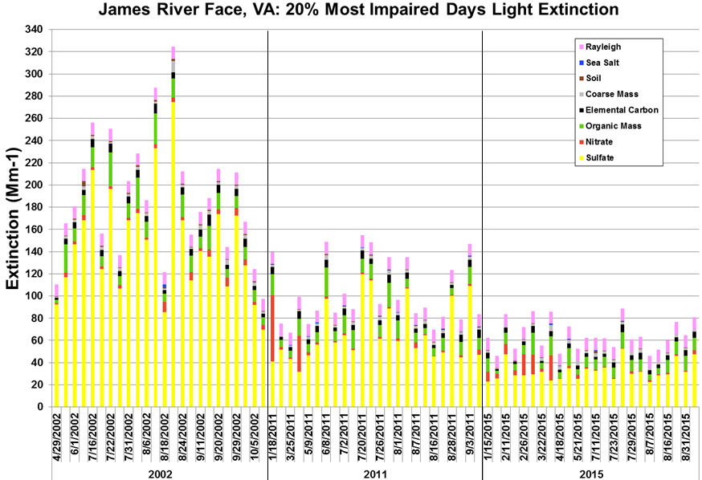

3.2 Percent Contribution Speciation Plots

Plots (see Figures 18-25) for each Class I area were created showing the percentage contribution for each of the species for 2002, 2011, 2015, 2000-04 (base 5-year period) and 2011-15 (current five year period). Sulfate light extinction percentage decreases for the regions Class I areas from 2000-04 to 2011-15 ranged from 17-28%. The resulting average light extinction percentage increase from Rayleigh scattering was 9-13% for northern Class I areas and 6-9% for Brigantine and other nearby Virginia and West Virginia Class I areas. Other significant (5% or more) light extinction component increases included:

- Lye Brook Wilderness - 5% from nitrates and 6% from organic carbon mass (note: higher because 2012-15 data from current method used instead of proposed method);
- Shenandoah National Park - 7% from nitrates;
- Dolly Sods Wilderness - 5% from nitrates; and
- Brigantine Wilderness - 13% from nitrates.

Figure 18: Acadia National Park 20% most impaired days light extinction speciation percentage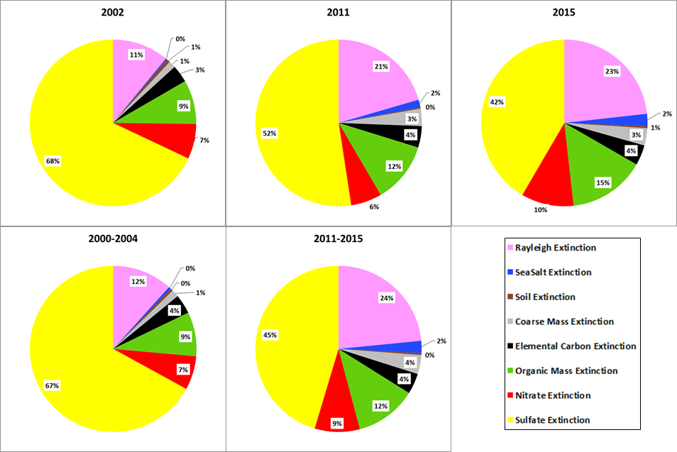
Figure 19: Moosehorn Wilderness 20% most impaired days light extinction speciation percentage
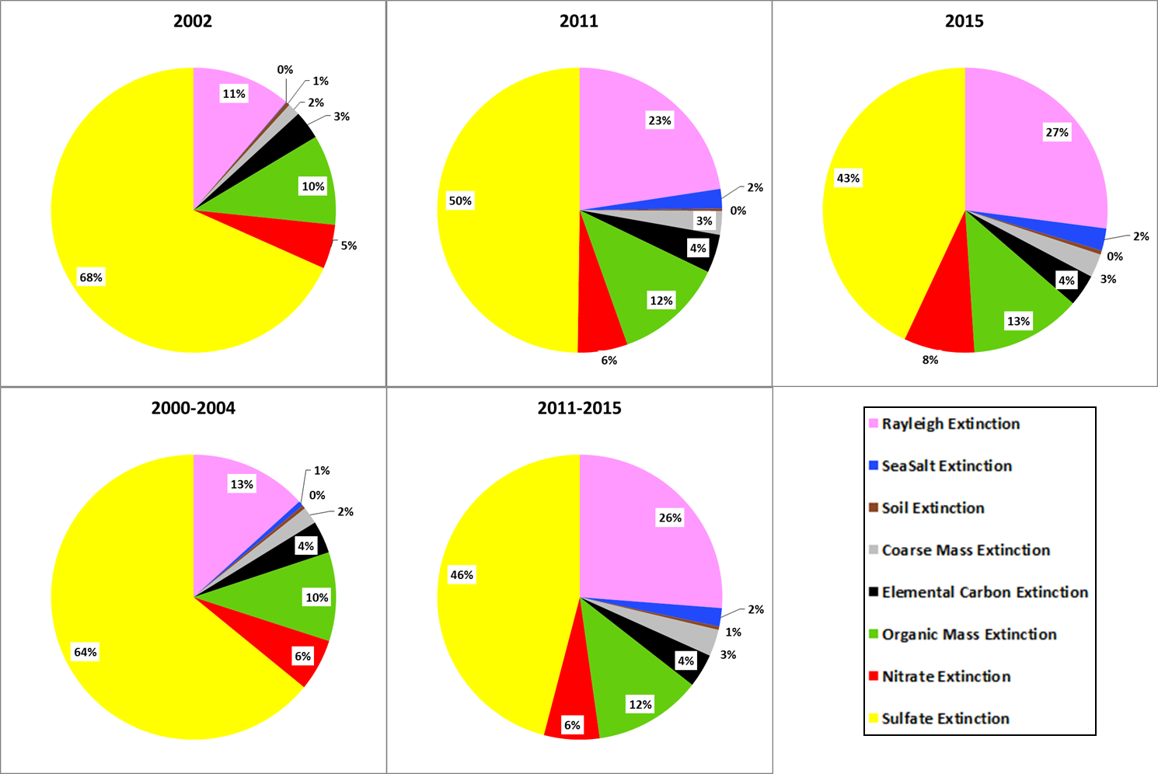
Figure 20: Great Gulf Wilderness 20% most impaired light extinction speciation percentage
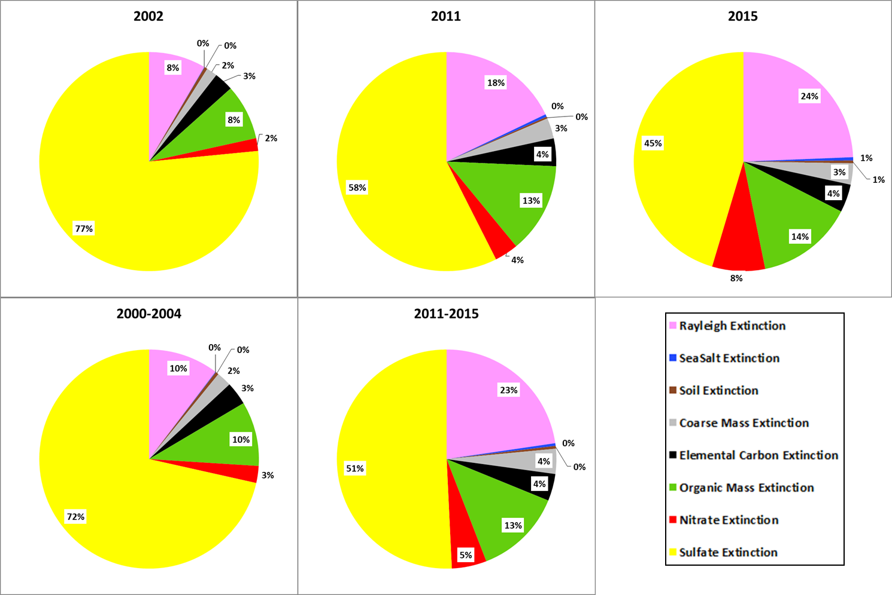
Figure 21: Lye Brook Wilderness 20% most impaired days light extinction speciation percentage
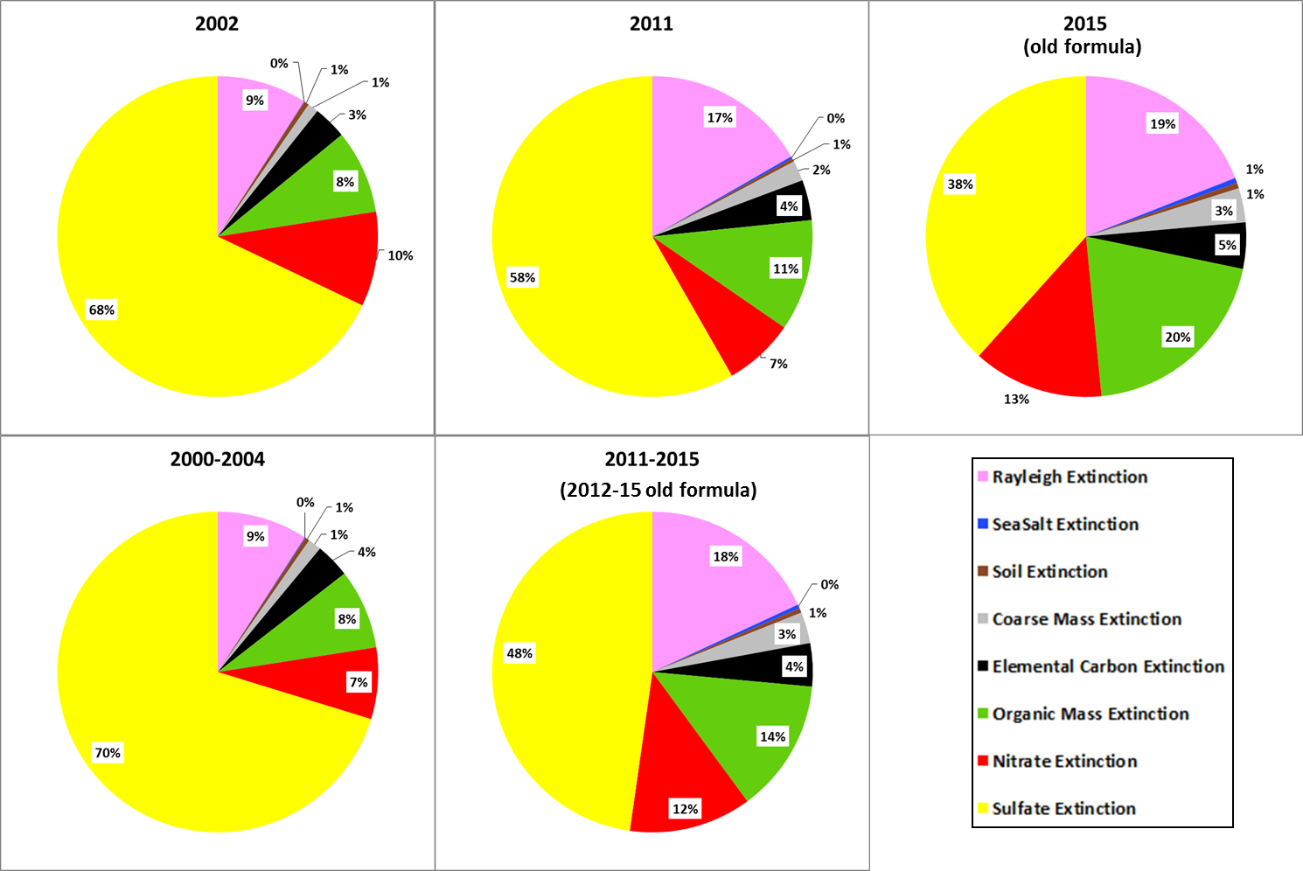
Figure 22: Brigantine Wilderness 20% most impaired days light extinction speciation percentage
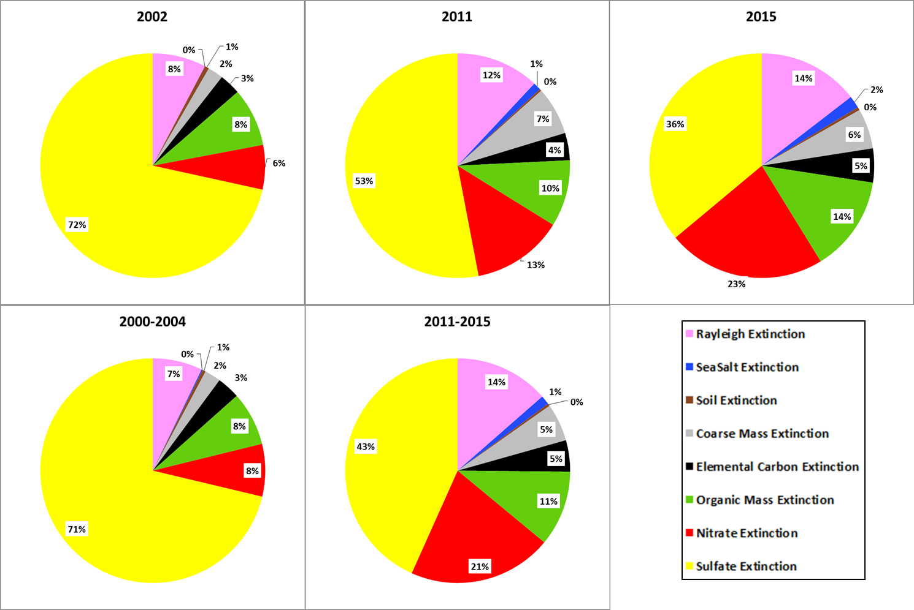
Figure 23: Shenandoah National Park 20% most impaired days light extinction speciation percentage
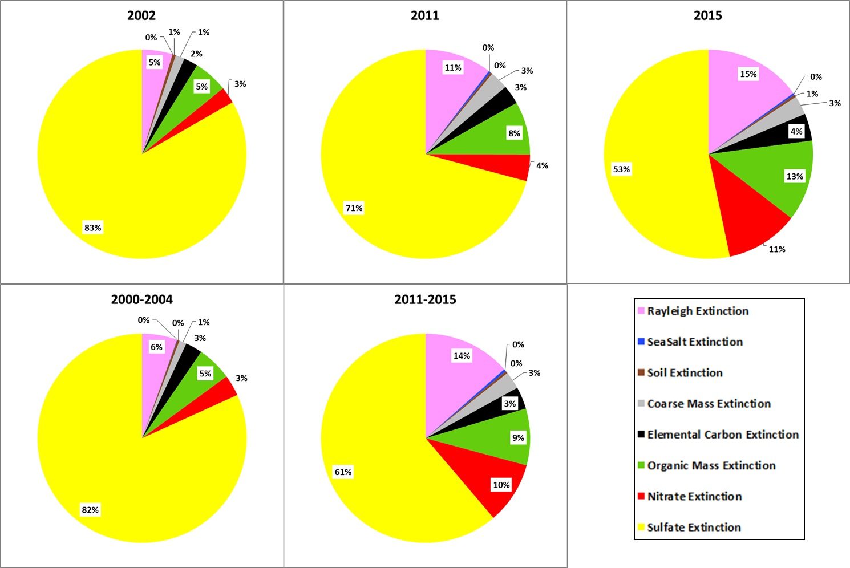
Figure 24: Dolly Sods Wilderness 20% most impaired days light extinction speciation percentage
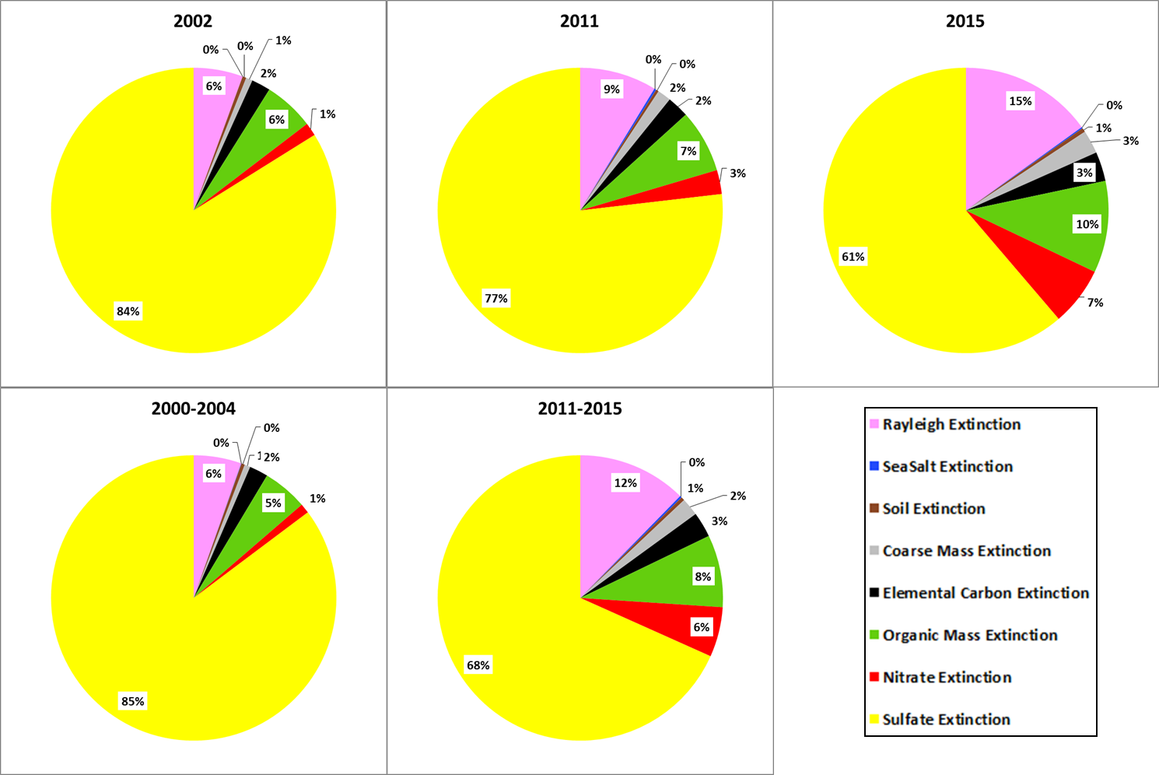
Figure 25: James River Face Wilderness 20% most impaired days light extinction speciation percentage
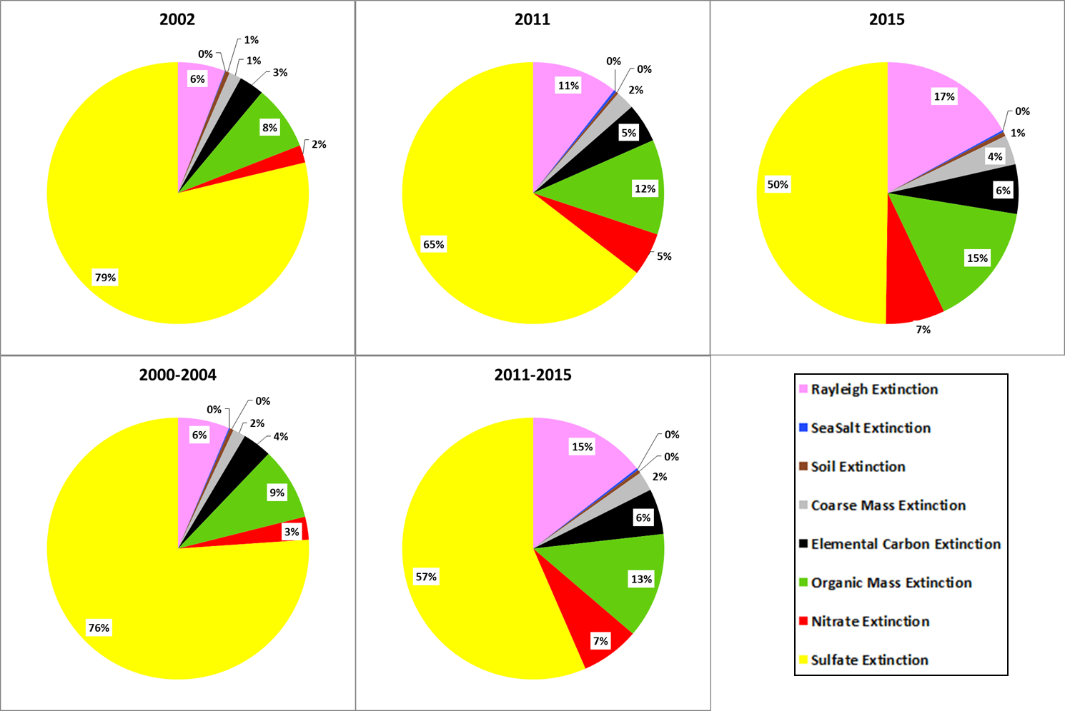
4.0 Trajectory Analysis

MEDEP-BAQ Air Quality Meteorologists conducted a back trajectory analysis for the 20% most impaired days for 2002, 2011 and 2015 at each of the five Class I Areas within MANE-VU as well as the three nearby Class I areas as listed in Section 2.0. Years chosen were the same years used in the 2016 MANE-VU Source Contribution Modeling Report (CALPUFF Modeling of Large Electrical Generation units and Industrial Sources).

A trajectory is a three dimensional representation of the path an air parcel followed based on forecast or archived meteorological data. A back trajectory is the path the parcel took to reach a specific point in time and space.

The National Oceanic and Atmospheric Administration (NOAA) Air Resources Laboratory’s HYSPLIT (HYbrid Single-Particle Lagrangian Integrated Trajectory) is a computer model used to create and map trajectories (Draxler and Hess December 1997). The model uses gridded meteorological data, which is selected within the online model’s GUI.

HYSPLIT is available for use online and also on a local computer (PC). MEDEP-BAQ staff meteorologists used the online version to create the trajectories included in this analysis. Archived EDAS meteorological (MET) data at 80 km was used for the dates in 2002 while EDAS at 40 km was for dates in 2011 & 2015 used because this data set had the best resolution and had an excellent data recovery rate. The previous trajectory analyses, Contributions to Regional Haze in the Northeast and Mid-Atlantic United States (NESCAUM 31 August 2006) performed for the first round of Regional Haze SIP was reviewed and it was determined due to resource restraints that the following settings within HYSPLIT would be used in this analysis to give states a general understanding of transport patterns during the 20% most impaired days for each Class I area:

- The model was set to include vertical velocity.
- Back trajectory length was set at 72 hours.
- Ending height was set to 500m above ground level.
- Four start times were set for each day -- 3AM, 9AM, 3PM and 9PM.

For each run, the HYSPLIT online model generates both a graphical presentation of the trajectories and a text file. The text file contains information about the hourly endpoints along each trajectory path including the location in time and space. These endpoint text files were saved and subsequently loaded into an Access database for each site. Each site’s database was then mapped in ARCMAP, a geographical mapping tool used within the department.

4.1 Trajectory Analysis Results

Trajectories can identify the frequency and general direction of air masses that are transported to a Class I area. However, trajectories don’t distinguish emissions density nor what area along the 72-hour projection is most likely to contribute emissions that impact the Class I areas. The results will be useful in combination with other contribution analyses.

Two types of maps were created for each Class I area. The first map will show the frequency (count) of hourly trajectory endpoints in each of the 25x25 mile grid points on a map to help define transport patterns to a Class I area during the most impaired visibility days. The second set of maps will show individual trajectories for each day to show seasonal differences in transport patterns. Note that you can also use the trajectory plots to look at potential impact from states in combination with other contribution analyses. CALPUFF modeling results (Mid-Atlantic Northeast Visibility Union April 2017) used for comparison with the trajectory analyses include states having an impacting EGU source or Industrial Source (industrial, commercial, and institutional) source with at least a 1 Mm⁻¹ light extinction impact to a Class I area. Detailed source impacts are in Appendix F of the CALPUFF modeling report. For EGU source impacts, results are for the more recent 2015 95th percentile emissions modeled using 2002, 2011 and 2015 meteorology. For Industrial Source source impacts, results are for 2011 typical emissions (2015 emissions not yet available) also modeled using 2002, 2011 and 2015 meteorology. Note that every day was modeled in the CALPUFF analysis not the 20% most impaired days. For each Class I area in the following subsections are a list of states meeting that criteria and trajectory plots for 2002, 2011 and 2015 20% most impaired days.

4.1.1 Acadia National Park

CALPUFF modeling results showed the following states (including the number of sources) meeting the criteria contributing to Acadia National Park regional haze impacts:

- MANE-VU Northeast states
  - Maine - 1 EGU and 4 Industrial Sources
  - Maryland - 2 EGUs and 1 Industrial Source
  - Massachusetts - 3 EGUs
  - New Hampshire - 4 EGUs
  - New York - 2 EGUs and 1 Industrial Source
  - Pennsylvania - 10 EGUs
- LADCO Midwest states
  - Illinois - 1 EGU
  - Indiana - 4 EGUs and 1 Industrial Source
  - Michigan - 7 EGUs
  - Ohio - 8 EGUs and 1 Industrial Source
- SESARM Southeast states
  - Georgia - 1 EGU
  - Kentucky - 3 EGUs
  - Tennessee - 1 EGU
  - Virginia - 2 EGUs and 1 Industrial Source
  - West Virginia - 2 EGUs

Trajectory plots for the 2002 (Figure 26), 2011 (Figure 27) and 2015 (Figure 28) 20% most impaired visibility days show trajectories from many regions including the states listed above. Transport patterns are similar for the three years. Other than the MANE-VU and Canadian regions, the strongest signal was from LADCO states and northern SESARM states. There was a strong signal from Canada due to a mixture of impacts from the high populated areas from Toronto to Montreal and from other areas of Canada with smoke impacts (higher OMC fraction) from forest fires.

Figure 26: Trajectory analyses of Acadia National Park most impaired days during 2002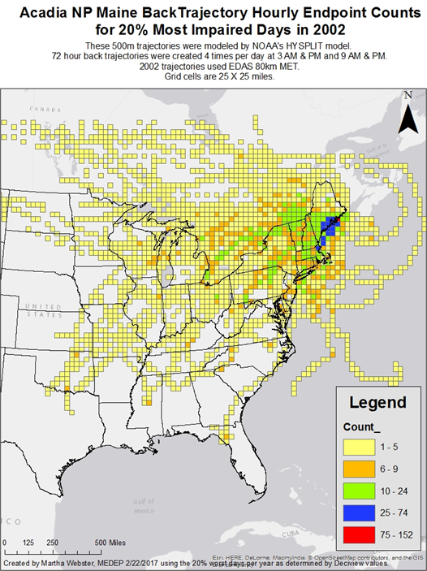
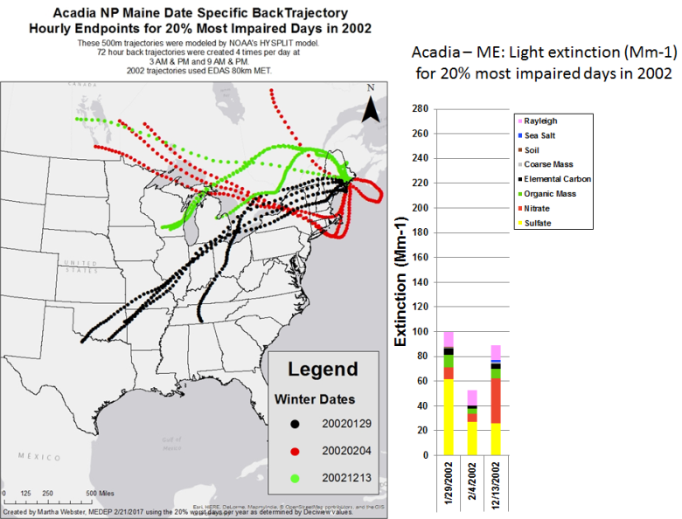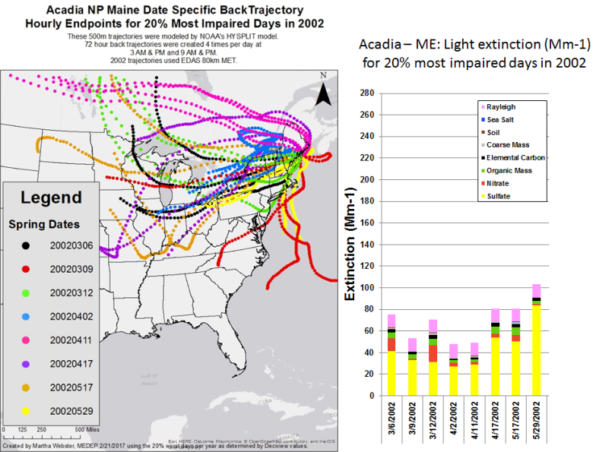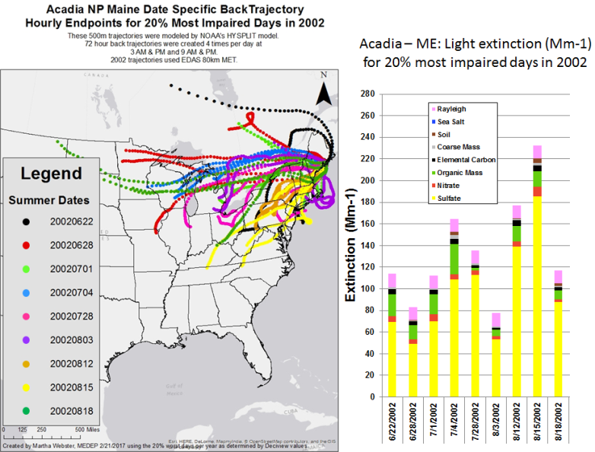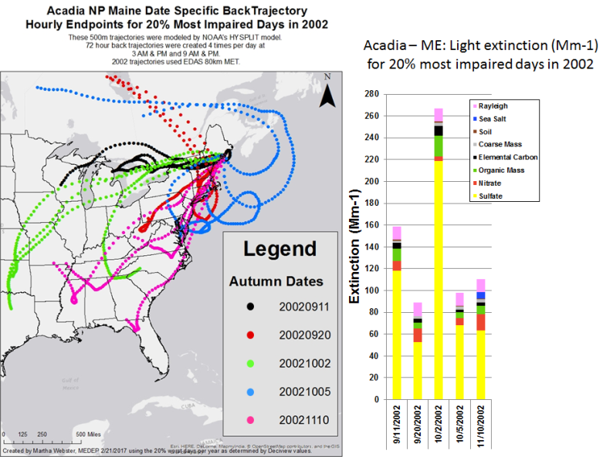
Figure 27: Trajectory analyses of Acadia National Park most impaired days during 2011
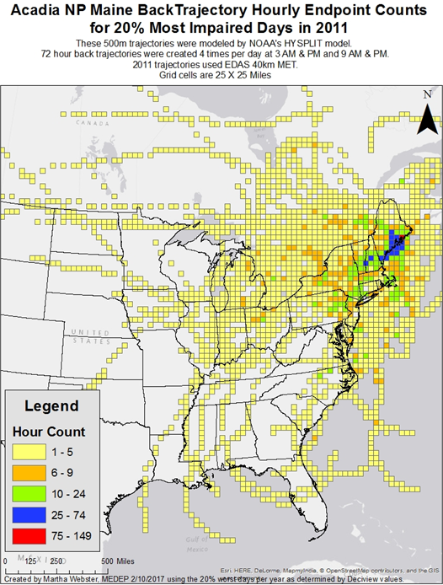
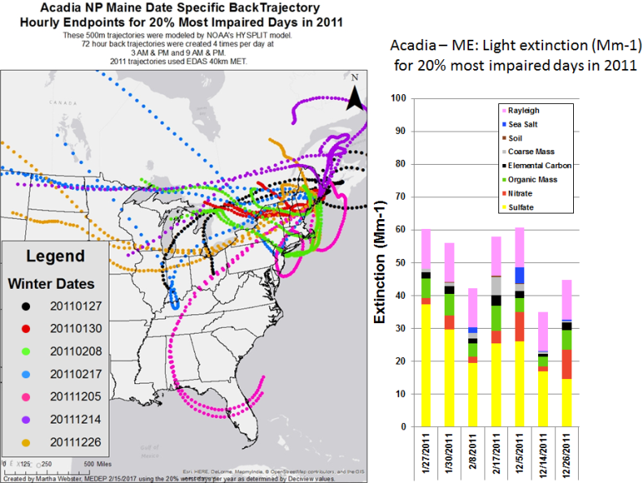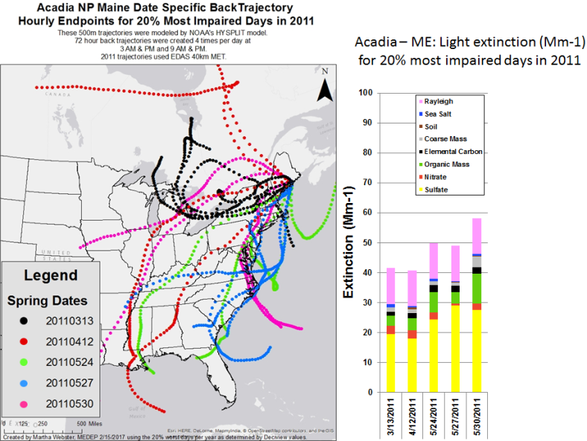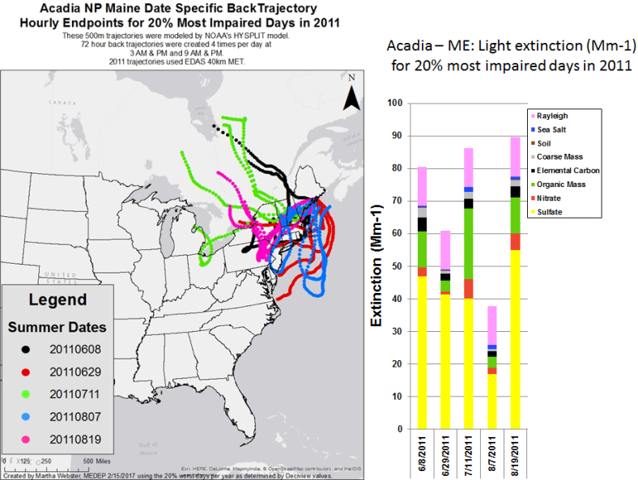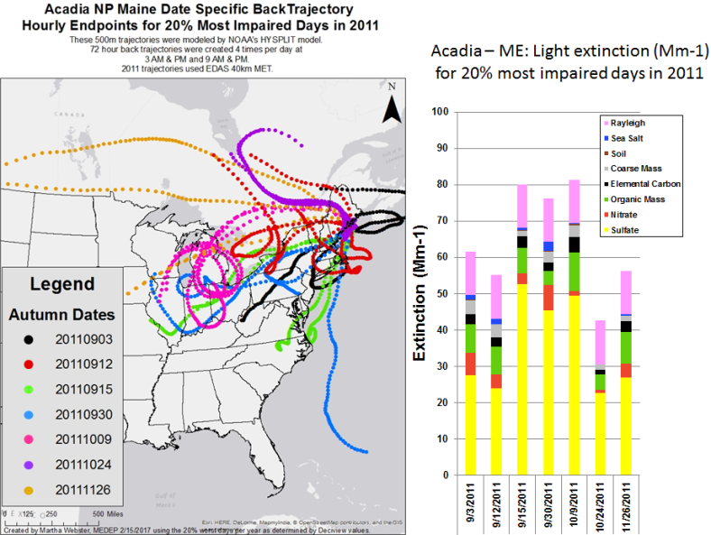
Figure 28: Trajectory analyses of Acadia National Park most impaired days during 2015
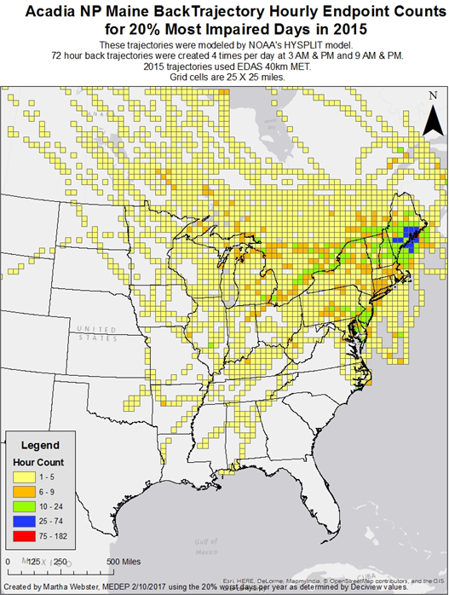
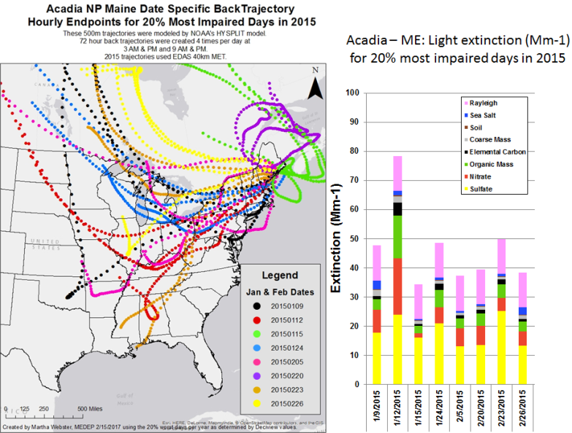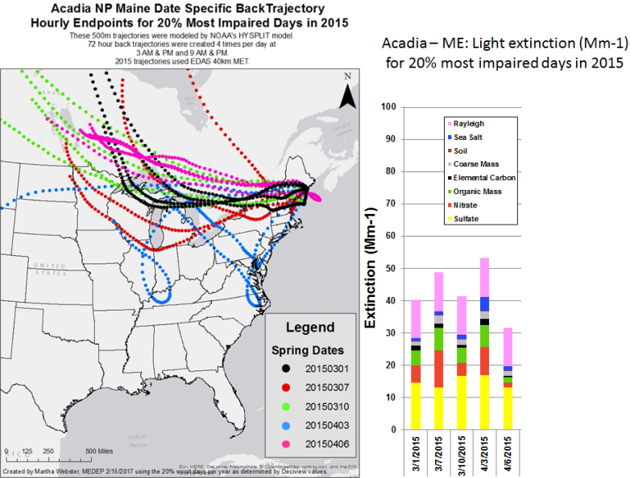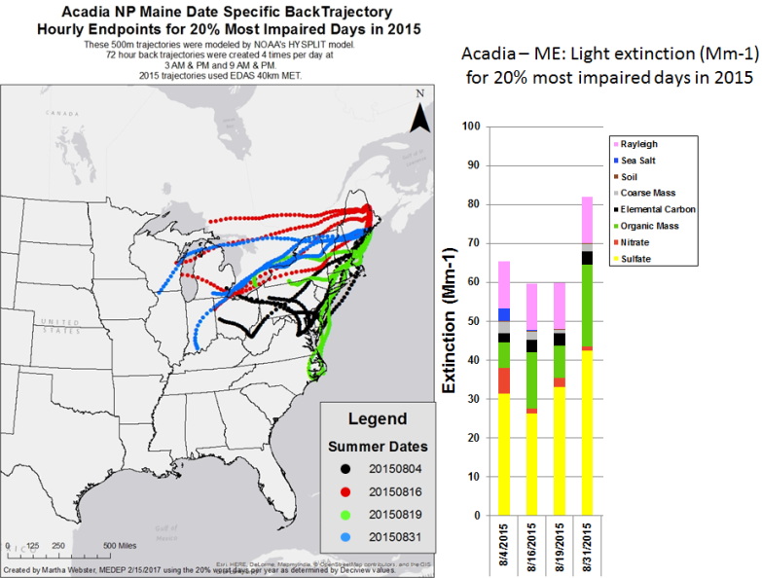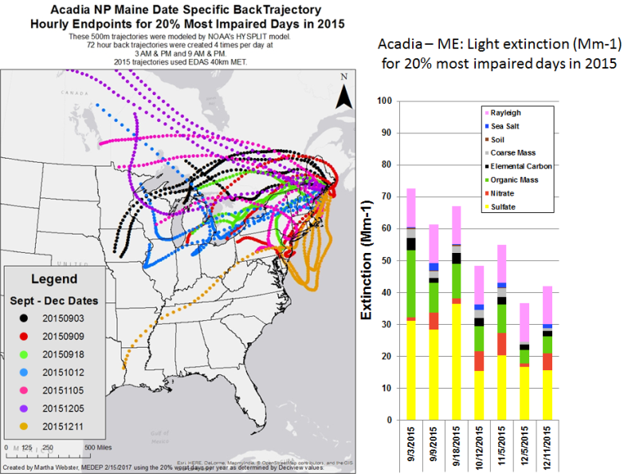

4.1.2 Moosehorn Wilderness Area

CALPUFF modeling results showed the following states meeting the criteria contributing to Moosehorn Wilderness regional haze impacts:

- MANE-VU Northeast states
  - Maine - 1 EGU and 2 Industrial Sources
  - Maryland - 1 EGU and 1 Industrial Source
  - Massachusetts - 3 EGUs
  - New Hampshire - 1 EGU
  - New York - 1 EGU and 1 Industrial Source
  - Pennsylvania - 9 EGUs
- LADCO Midwest states
  - Illinois - 1 EGU
  - Indiana - 4 EGUs and 1 Industrial Source
  - Michigan - 6 EGUs
  - Ohio - 7 EGUs and 1 Industrial Source
- SESARM Southeast states
  - Georgia - 1 EGU
  - Kentucky - 2 EGUs
  - Tennessee - 1 EGU
  - Virginia - 2 EGUs
  - West Virginia - 2 EGUs

Trajectory plots for the 2002 (Figure 29), 2011 (Figure 30) and 2015 (Figure 31) 20% most impaired visibility days show trajectories from all the states listed. Transport patterns are similar for the three years. Other than the MANE-VU and Canadian regions, the strongest signal was from LADCO and northern SESARM states. Similar to the Acadia National Park trajectories, there was a very strong signal from Canada.

Figure 29: Trajectory analyses of Moosehorn Wilderness most impaired days during 2002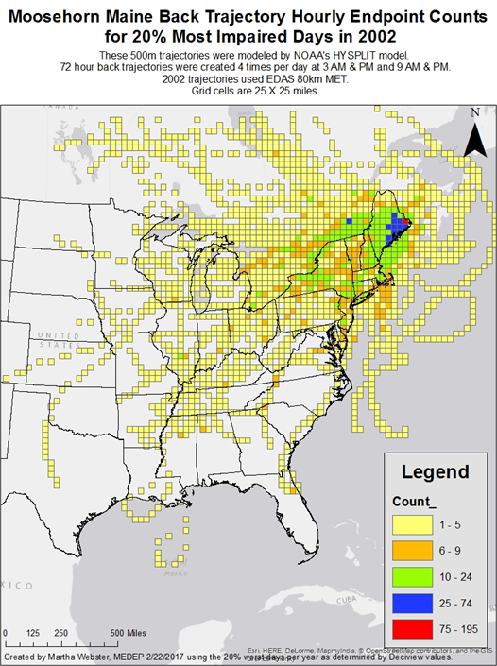
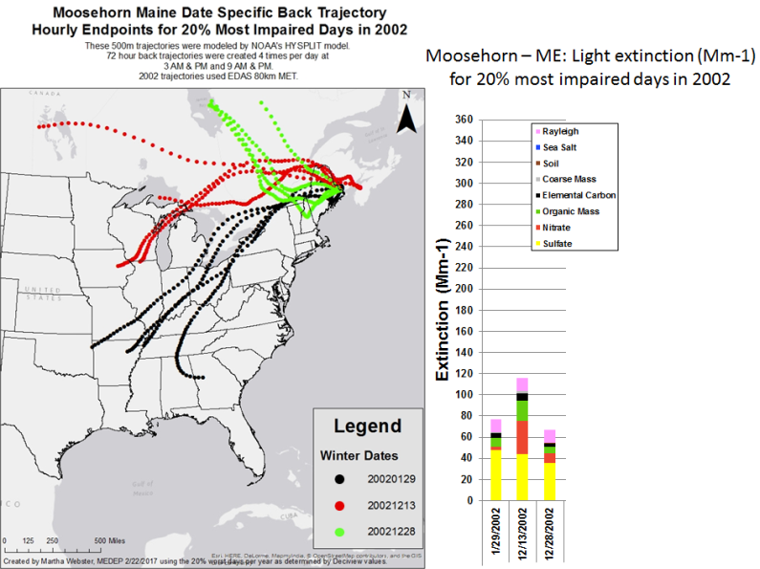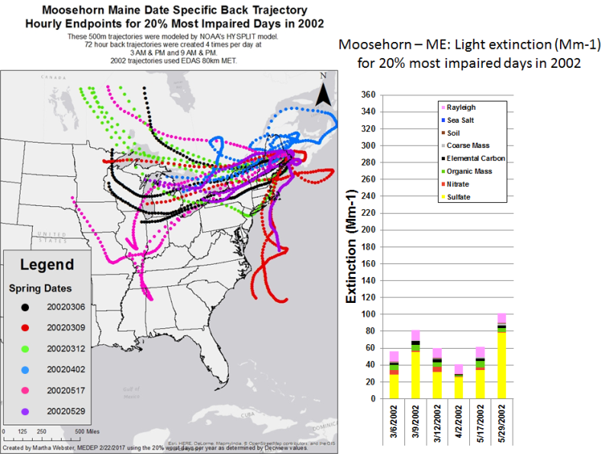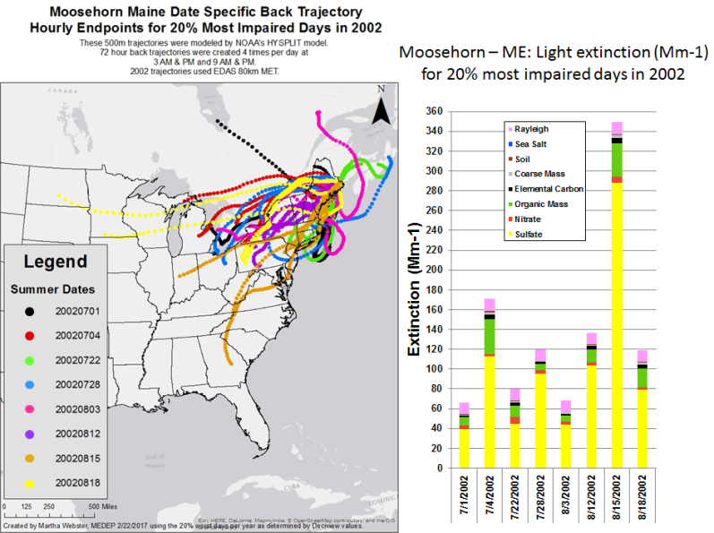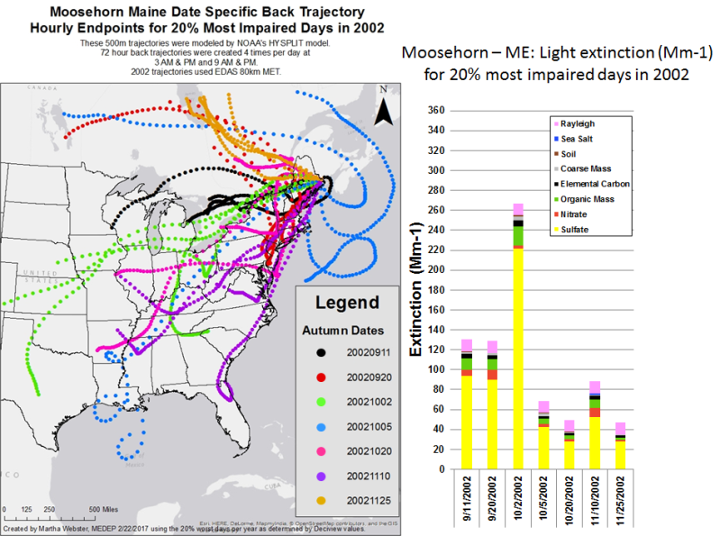
Figure 30: Trajectory analyses of Moosehorn Wilderness most impaired days during 2011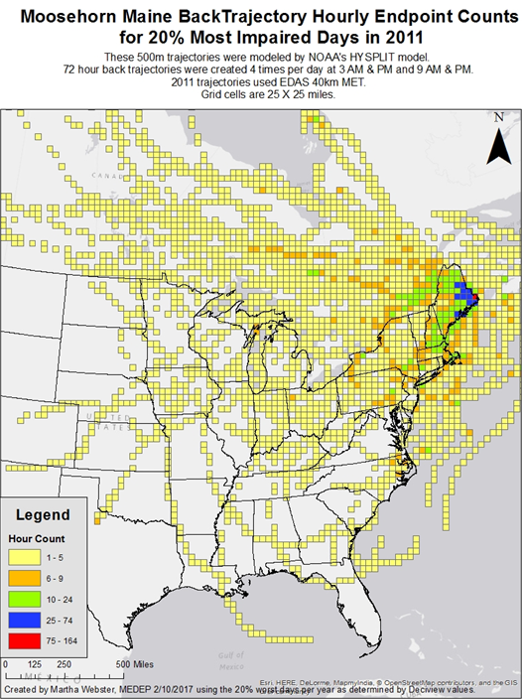
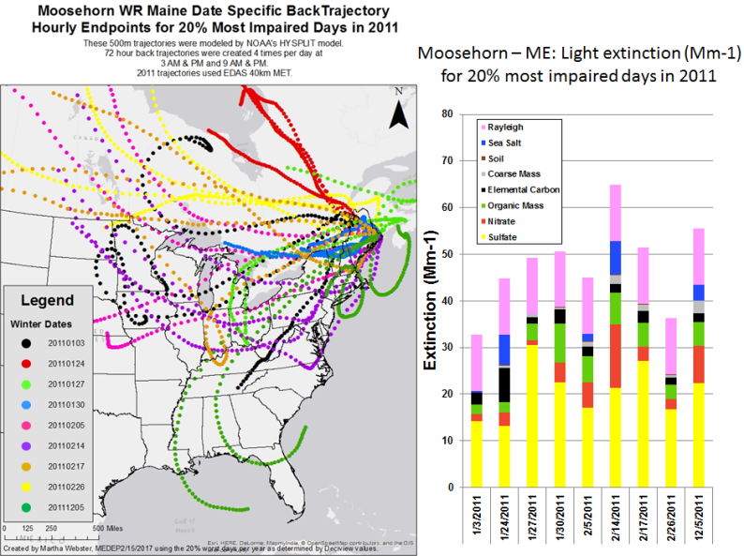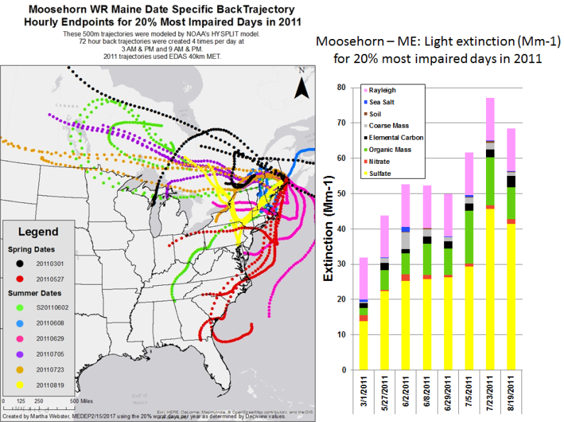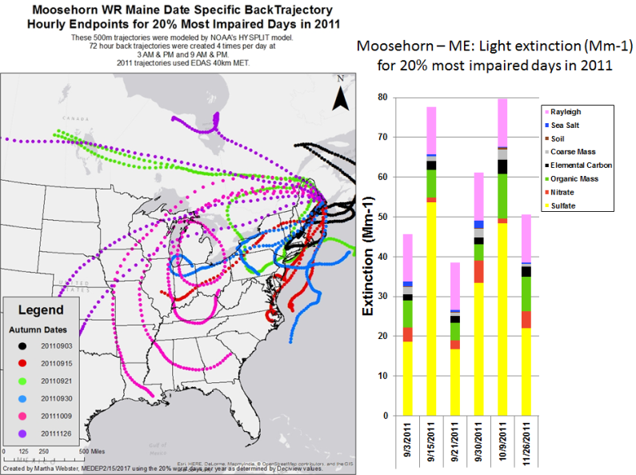

Figure 31: Trajectory analyses of Moosehorn Wilderness most impaired days during 2015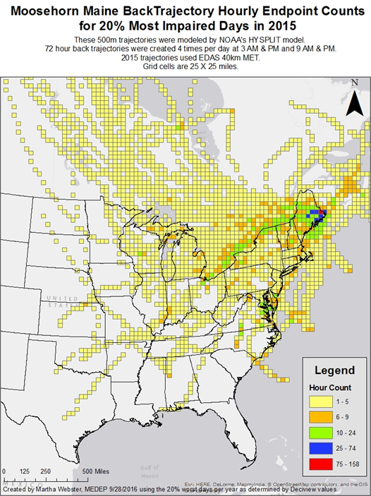
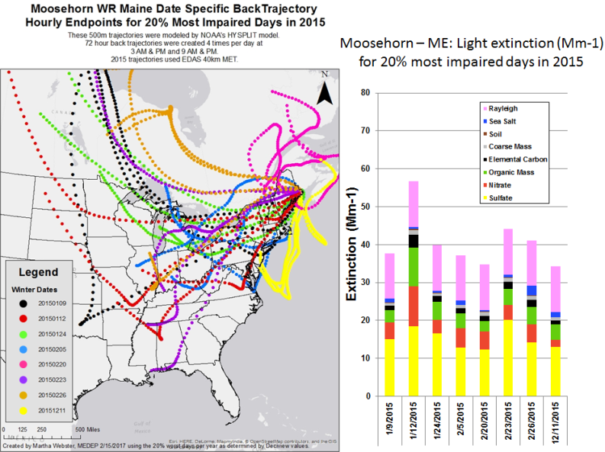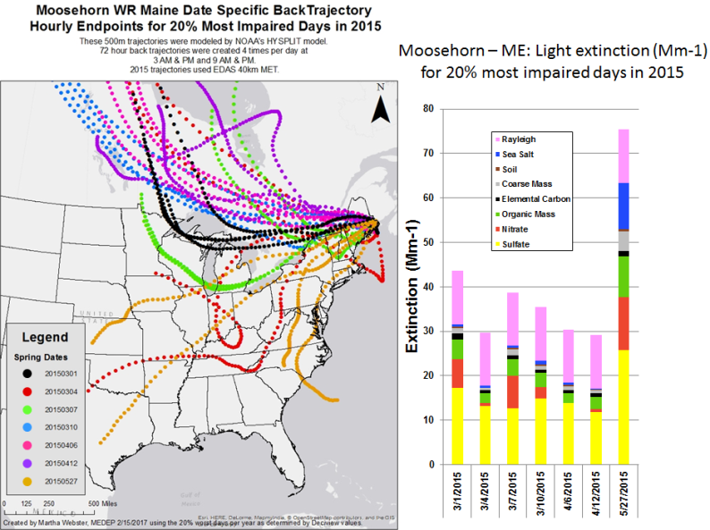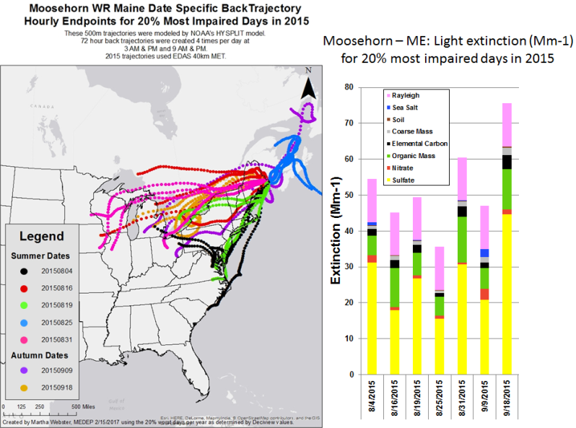
4.1.3 Great Gulf Wilderness Area

CALPUFF modeling results showed the following states meeting the criteria contributing to Great Gulf Wilderness regional haze impacts:

- MANE-VU Northeast states
  - Maine - 1 EGU and 2 Industrial Sources
  - Maryland – 1 Industrial Source
  - Massachusetts - 1 EGU
  - New Hampshire - 3 EGUs
  - New York - 2 EGUs and 2 Industrial Sources
  - Pennsylvania - 11 EGUs
- LADCO Midwest states
  - Illinois - 1 EGU
  - Indiana - 4 EGUs and 1 Industrial Source
  - Michigan - 8 EGUs
  - Ohio - 9 EGUs and 1 Industrial Source
- SESARM Southeast states
  - Georgia - 1 EGU
  - Kentucky - 1 EGU
  - Virginia - 2 EGUs and 1 Industrial Source
  - West Virginia - 4 EGUs

Trajectory plots for the 2002 (Figure 32), 2011 (Figure 33) and 2015 (Figure 34) 20% most impaired visibility days show trajectories from all the states listed above. Other than the MANE-VU and Canadian regions, during 2011 and 2015 the strongest signal was from LADCO and northern SESARM states. Similar to other northern Class I areas, there was a strong signal from Canada. It was only during the winter of 2015 where there was a signal from Georgia.

Figure 32: Trajectory analyses of Great Gulf Wilderness most impaired days during 2002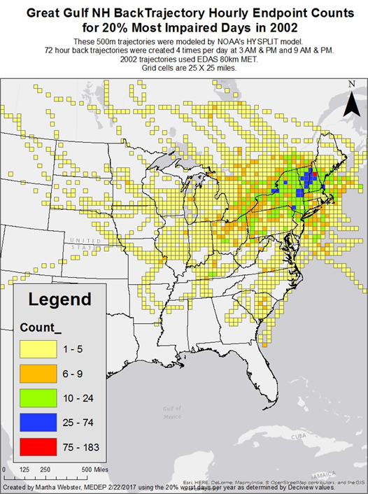
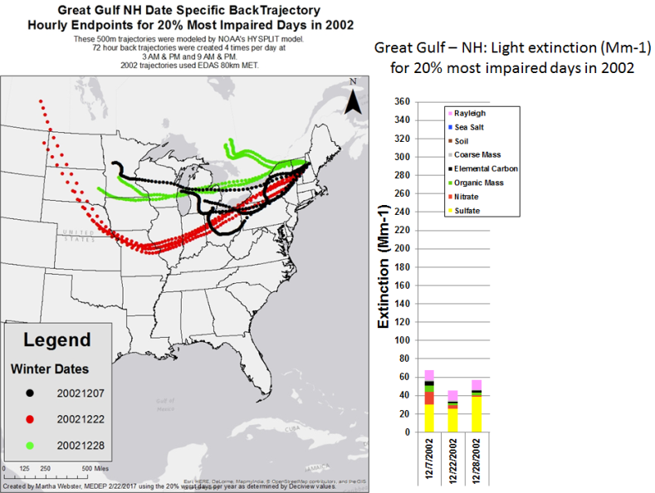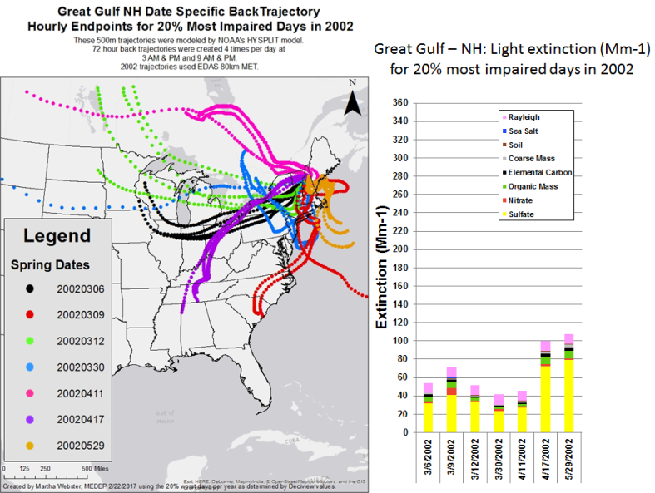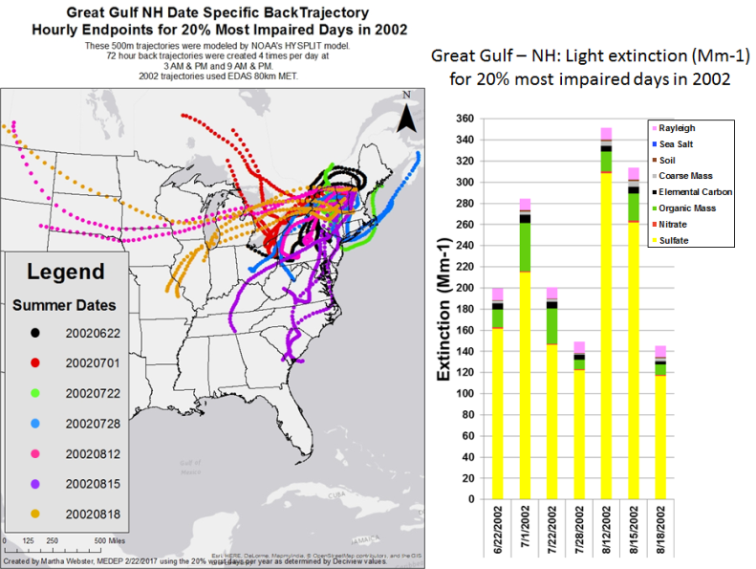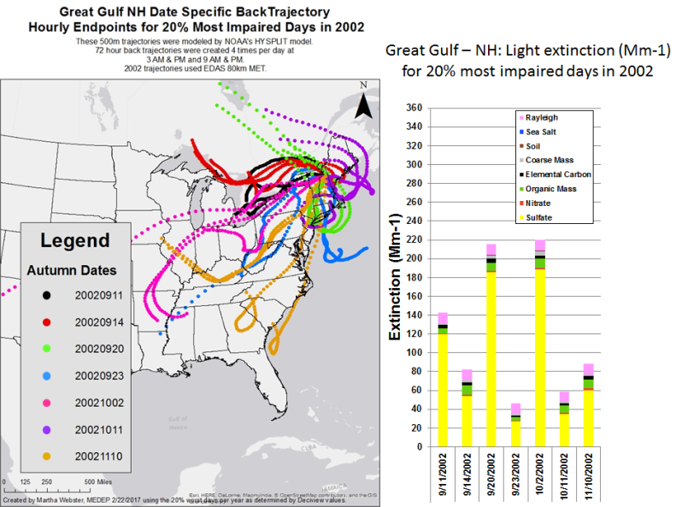
Figure 33: Trajectory analyses of Great Gulf Wilderness most impaired days during 2011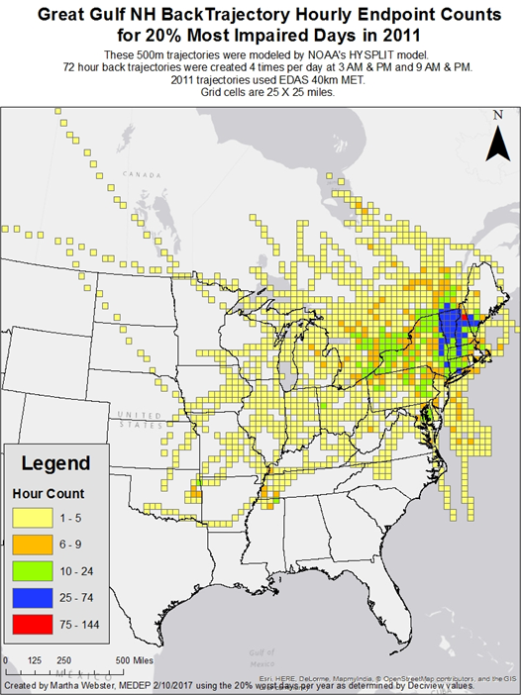
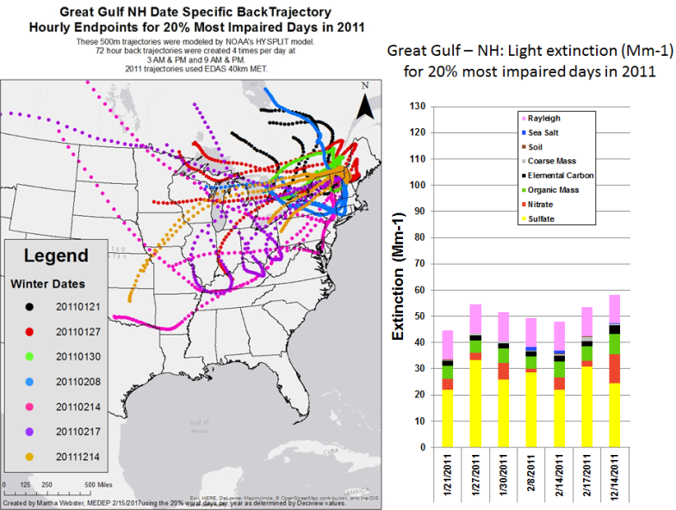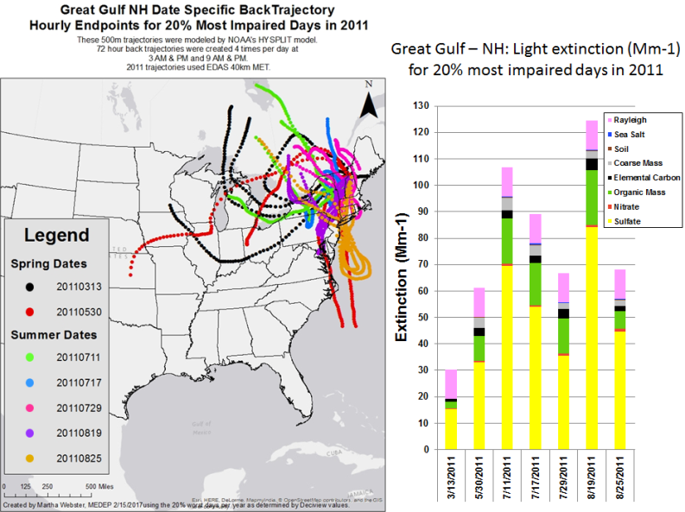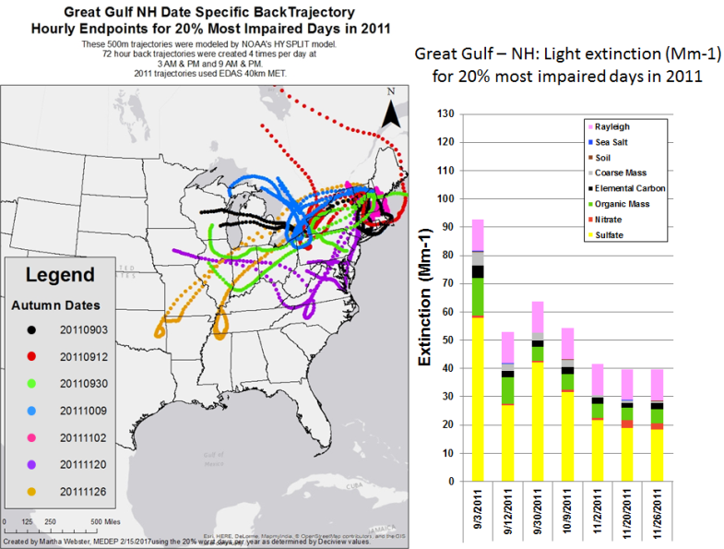
Figure 34: Trajectory analyses of Great Gulf Wilderness most impaired days during 2015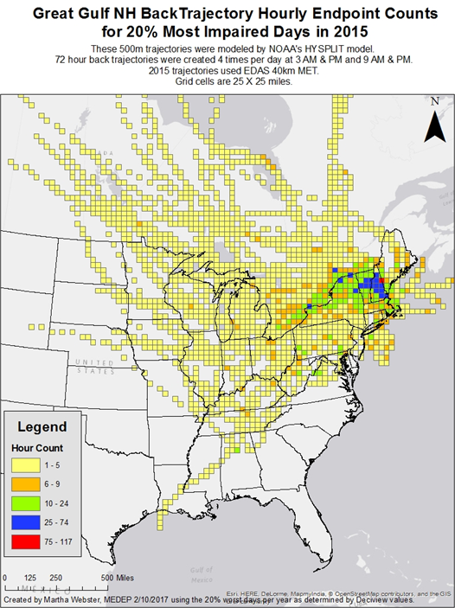
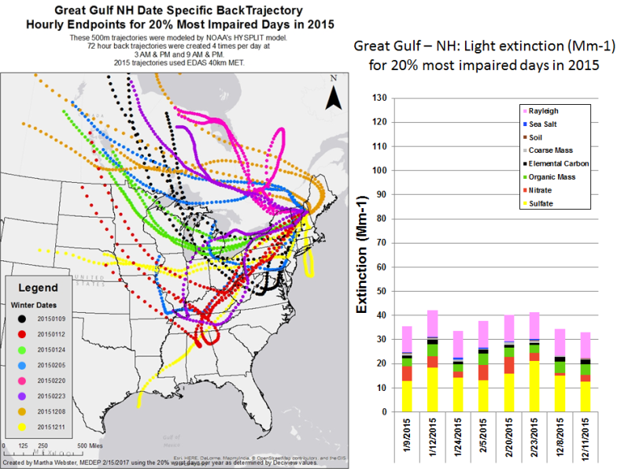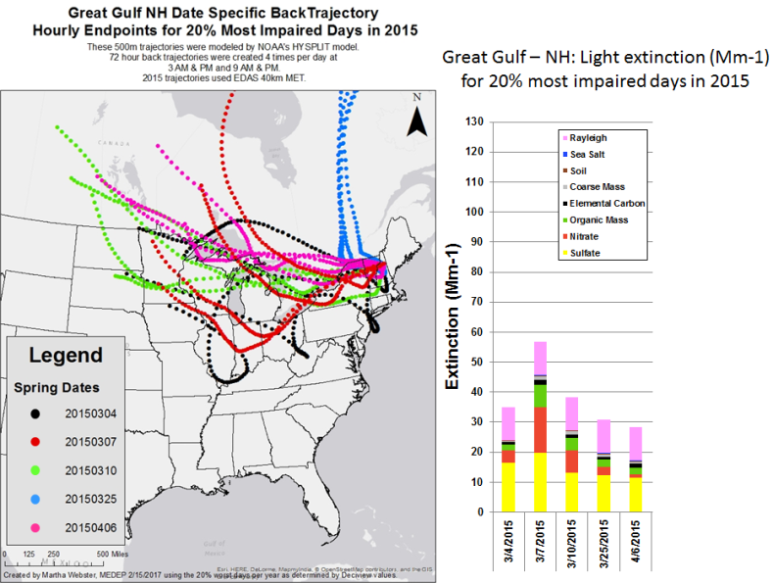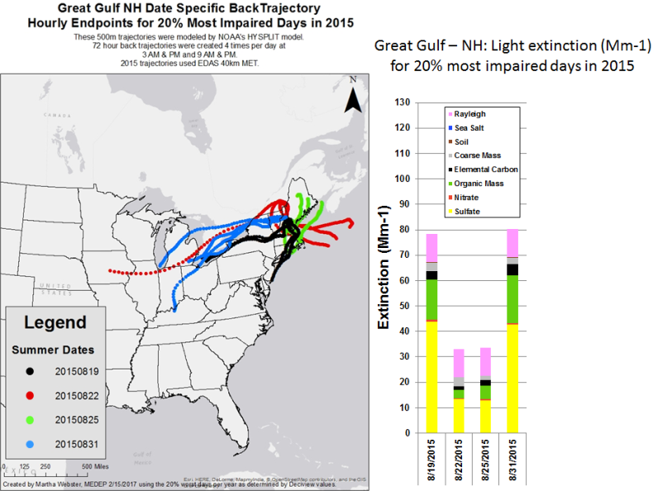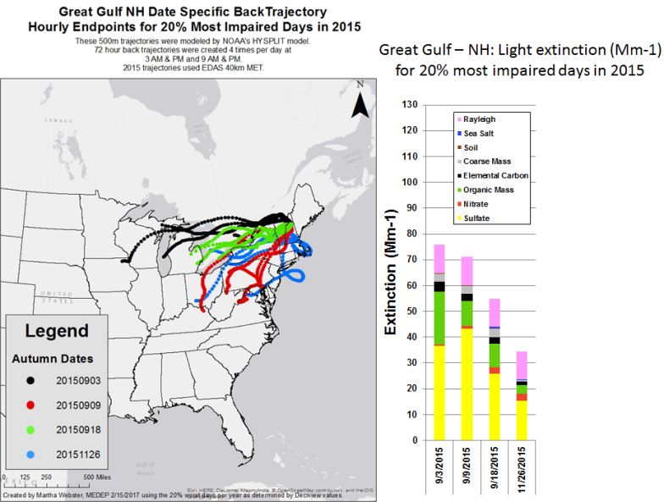

4.1.4 Lye Brook Wilderness Area

CALPUFF modeling results showed the following states meeting the criteria contributing to Lye Brook Wilderness regional haze impacts:

- MANE-VU Northeast states
  - Maine - 1 EGU and 1 Industrial Source
  - Maryland - 1 EGU and 1 Industrial Source
  - Massachusetts - 2 EGUs
  - New Hampshire - 3 EGUs
  - New York - 3 EGUs and 4 Industrial Sources
  - Pennsylvania - 12 EGUs
- LADCO Midwest states
  - Indiana - 4 EGUs and 1 Industrial Source
  - Michigan - 7 EGUs
  - Ohio - 9 EGUs and 1 Industrial Source
- SESARM Southeast states
  - Georgia - 1 EGU
  - Kentucky - 2 EGUs
  - Tennessee - 1 Industrial Source
  - Virginia - 2 EGUs
  - West Virginia – 4 EGUs
- CENRAP Central states
  - Missouri 1 EGU
  - Texas 2 EGUs

Trajectory plots for the 2002 (Figure 35) and 2011 (Figure 36) most impaired visibility days and 2015 (Figure 37) 20% worst visibility days show trajectories from all the states listed above except for Texas. Other than the MANE-VU and Canadian regions, the strongest signals were from LADCO and northern SESARM states. As was the case for other northern Class I areas, there was also a signal from Canada.

Figure 35: Trajectory analyses of Lye Brook Wilderness most impaired days during 2002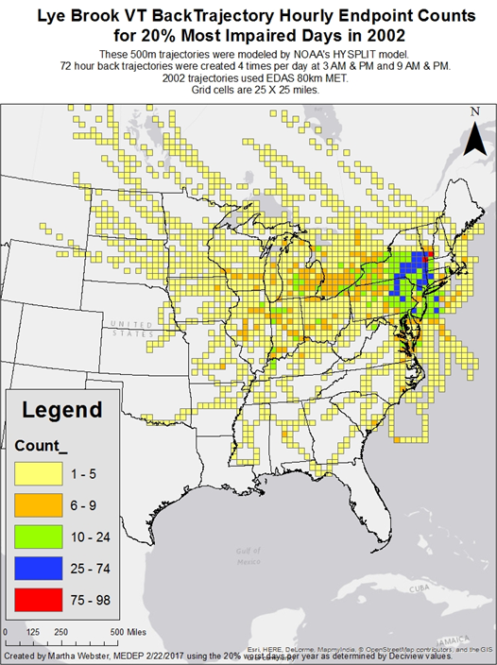
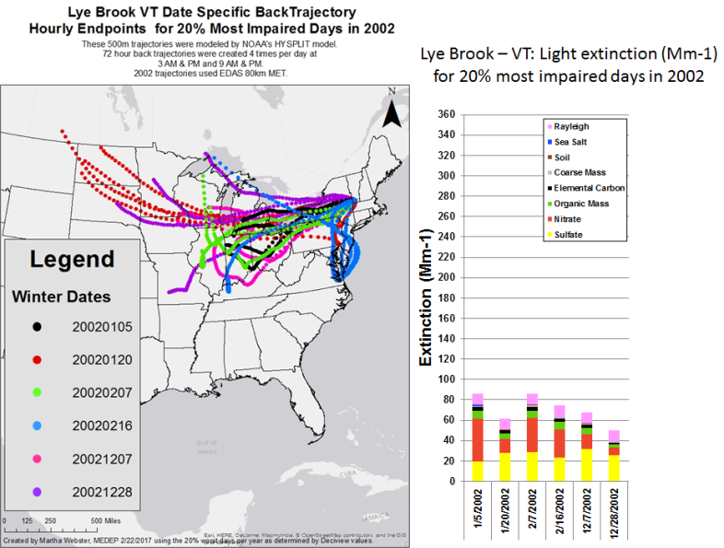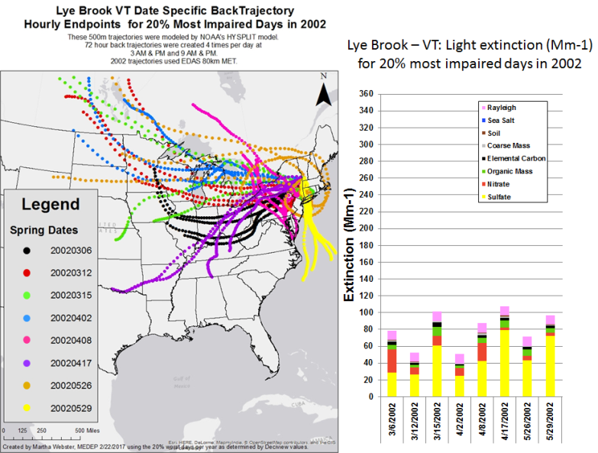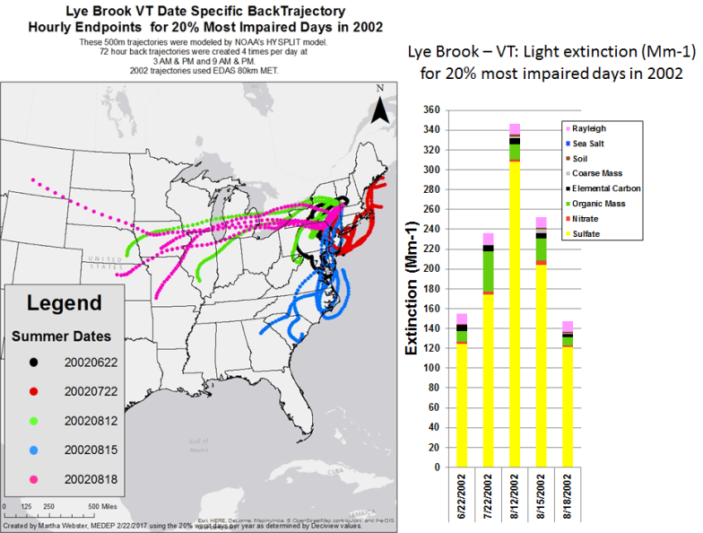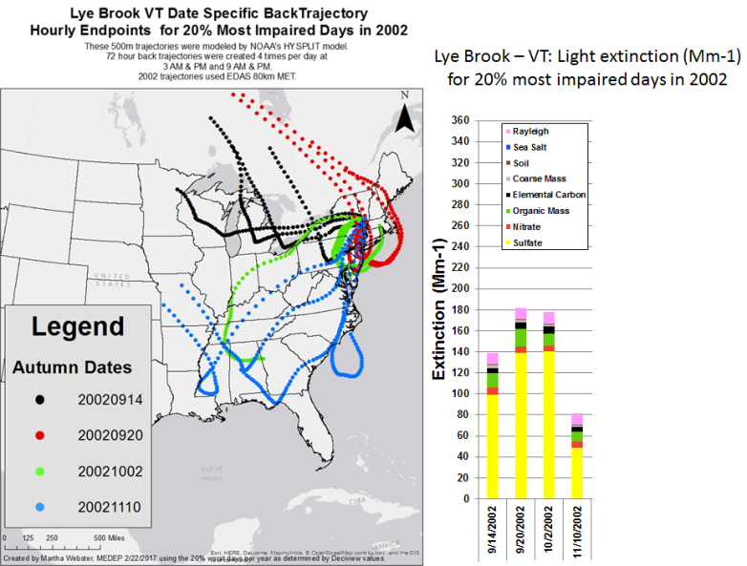
Figure 36: Trajectory analyses of Lye Brook Wilderness most impaired days during 2011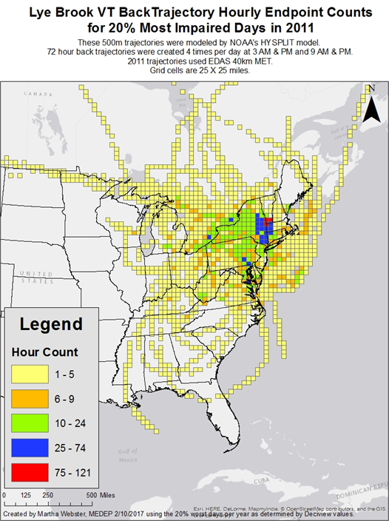
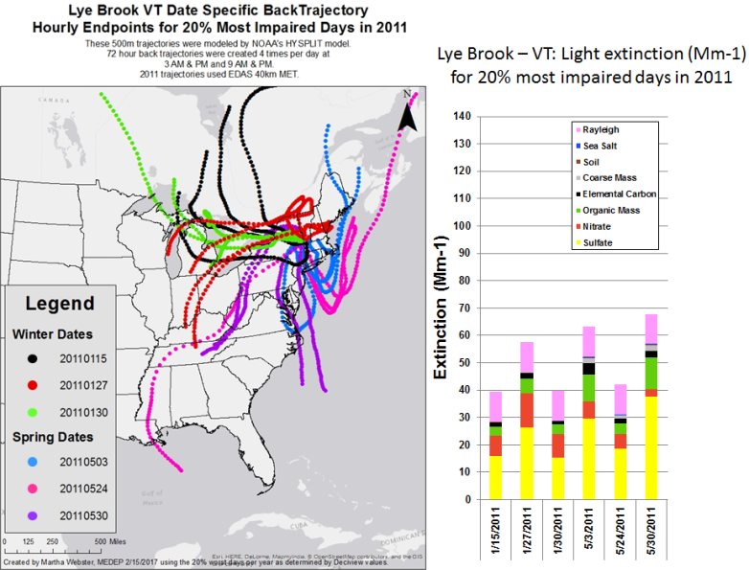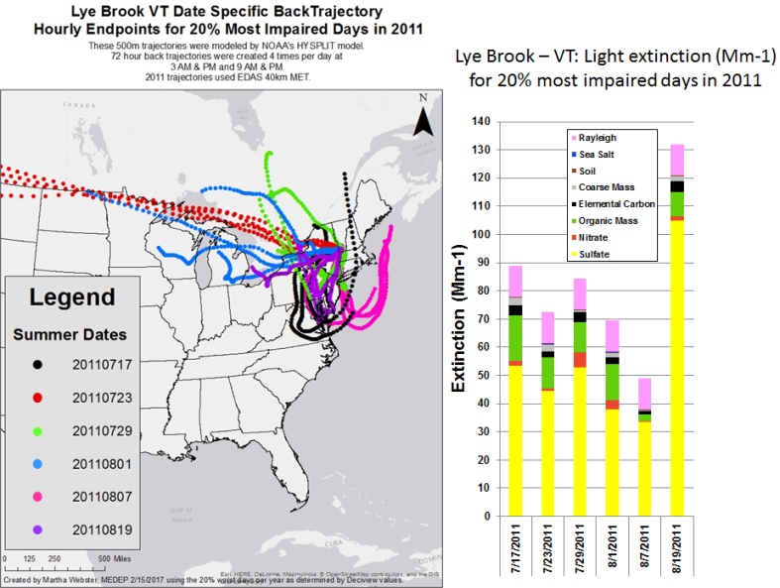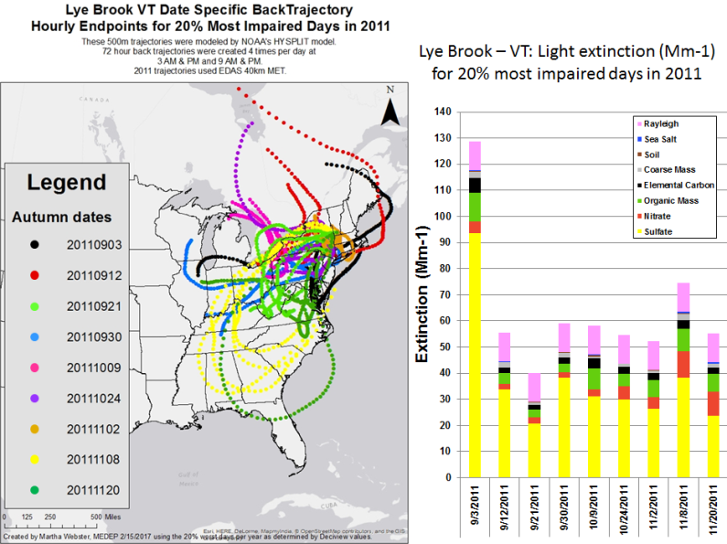
Figure 37: Trajectory analyses of Lye Brook Wilderness 20% worst days during 2015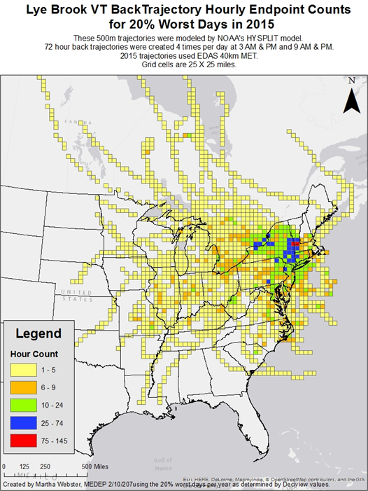
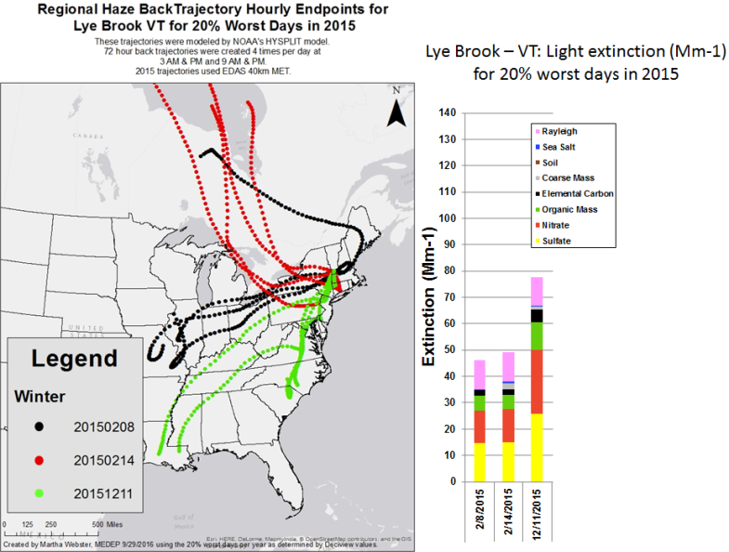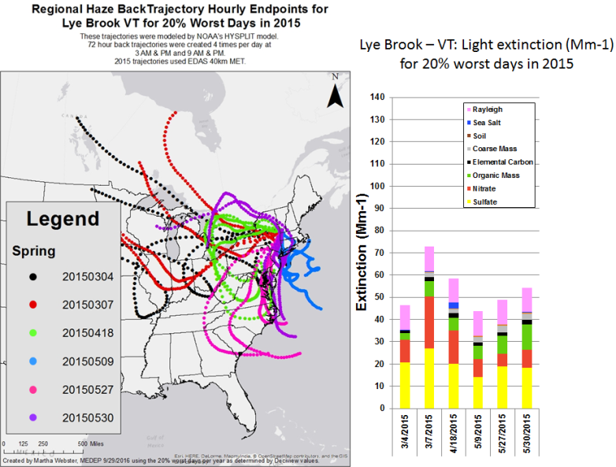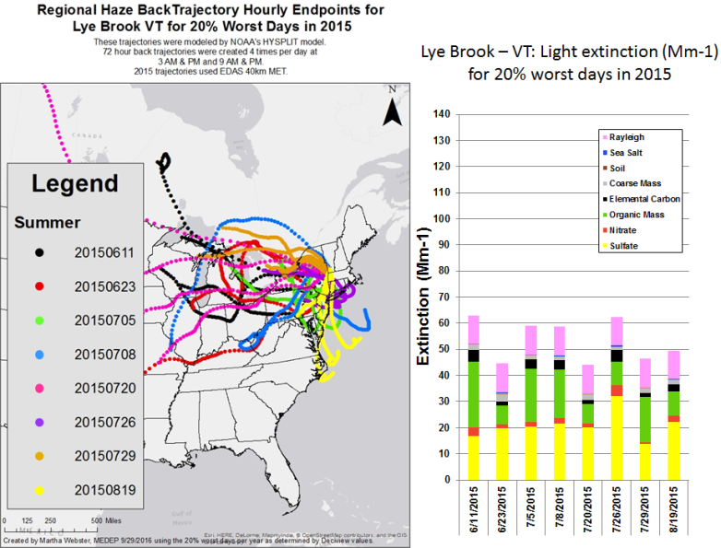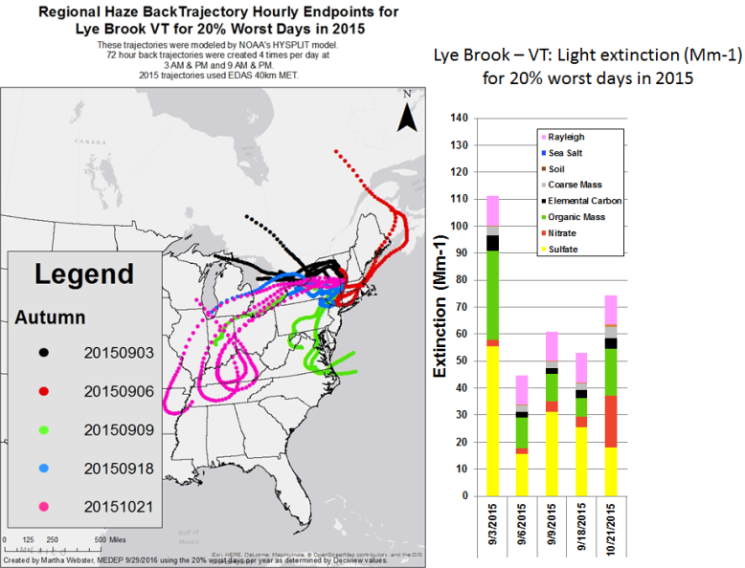

4.1.5 Brigantine Wilderness Area

CALPUFF modeling results showed the following states meeting the criteria contributing to Brigantine regional haze impacts:

- MANE-VU Northeast states
  - Connecticut – 1 EGU
  - Massachusetts - 3 EGUs
  - Maryland - 6 EGUs and 2 Industrial Sources
  - Maine 1 EGU
  - New Jersey 1 EGU and 1 Industrial Source
  - New York - 2 EGUs and 1 Industrial Source
  - Pennsylvania - 12 EGUs and 2 Industrial Sources
- LADCO Midwest states
  - Illinois - 1 EGU
  - Indiana - 5 EGUs and 1 Industrial Source
  - Michigan - 8 EGUs
  - Ohio - 9 EGUs and 1 Industrial Source
- SESARM Southeast states
  - Alabama – 1 EGU
  - Georgia - 2 EGUs
  - Kentucky - 3 EGUs
  - North Carolina – 2 EGUs and 1 Industrial Source
  - Tennessee - 1 EGU and 1 Industrial Source
  - Virginia - 2 EGUs and 2 Industrial Sources
  - West Virginia - 5 EGUs
- CENRAP Central states
  - Texas – 2 EGUs

Trajectory plots for the 2002 (Figure 38), 2011 (Figure 39) and 2015 (Figure 40) 20% most impaired visibility days show trajectories from all the LADCO and SESARM states listed above. Other than the MANE-VU and Canadian regions, during 2011 and 2015 there were strong signals from Great Lake states, Ohio Valley states and Virginia.

Figure 38: Trajectory analyses of Brigantine Wilderness most impaired days during 2002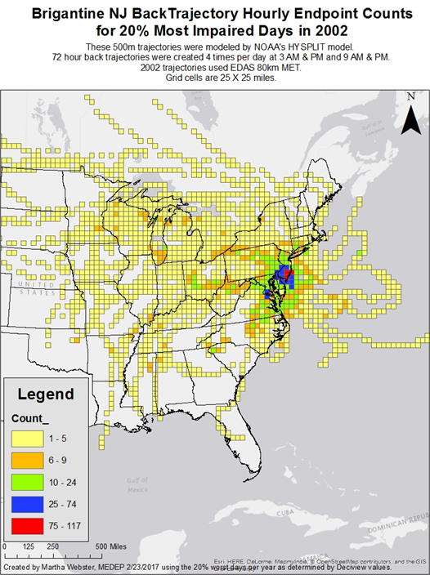
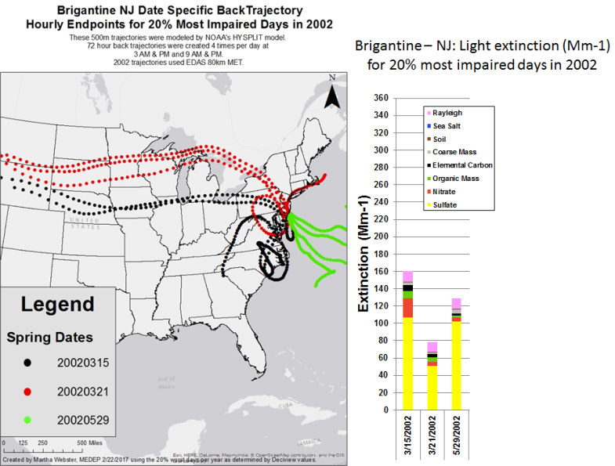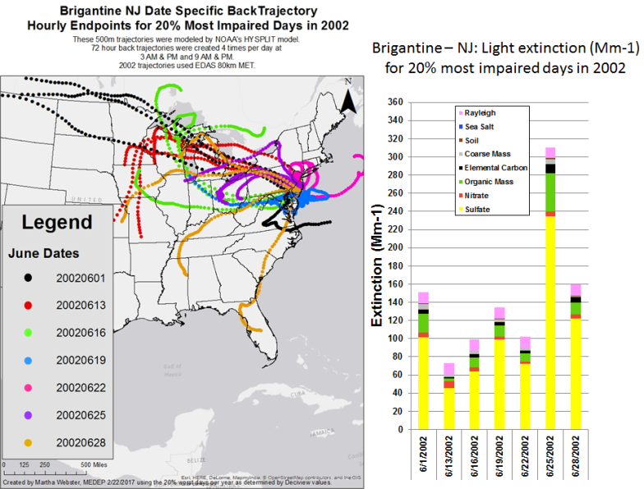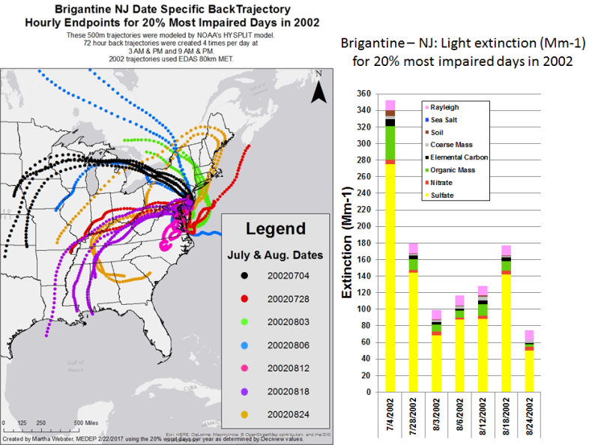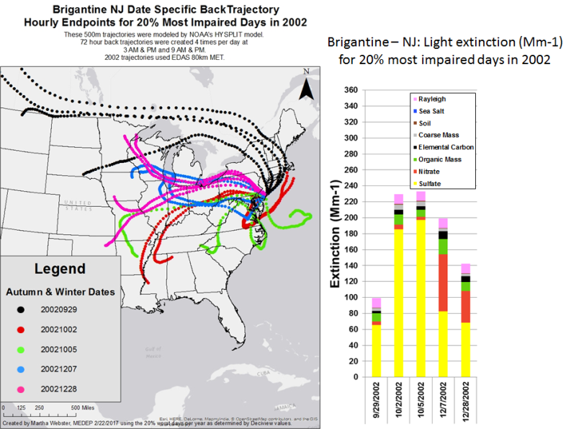
Figure 39: Trajectory analyses of Brigantine Wilderness most impaired days during 2011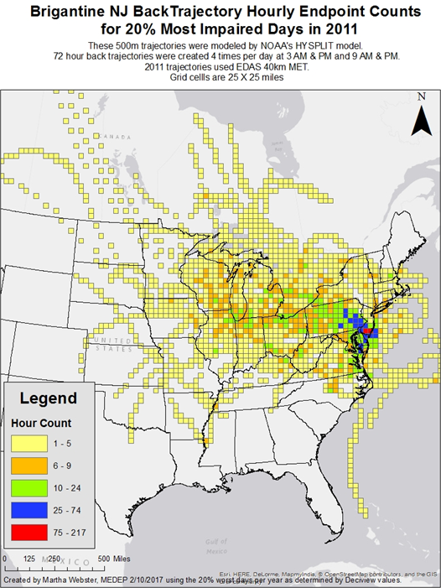
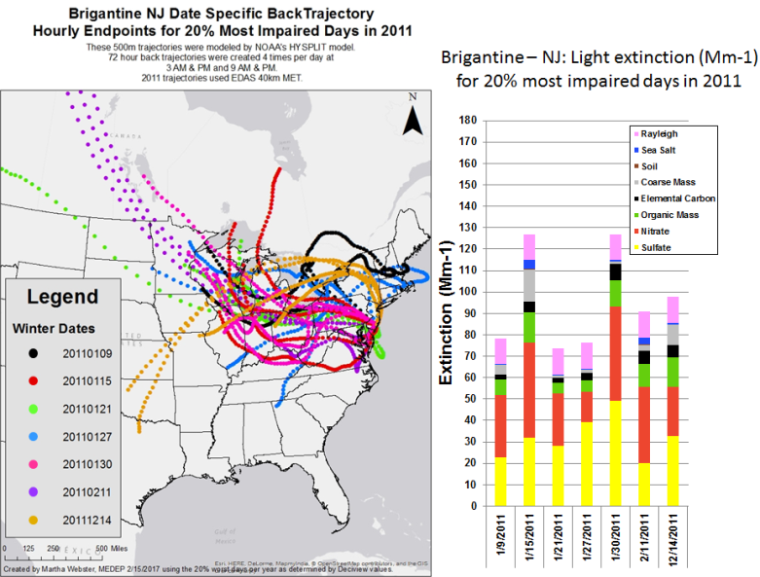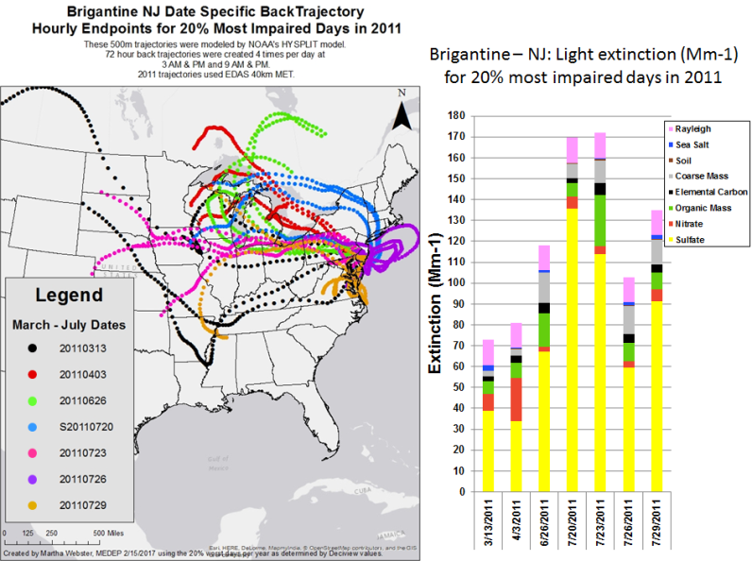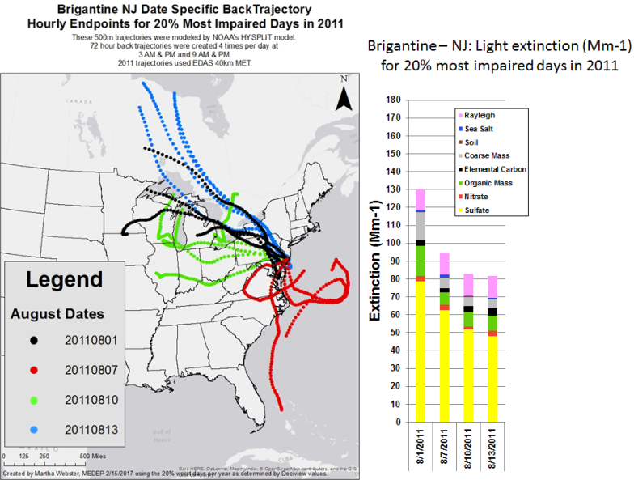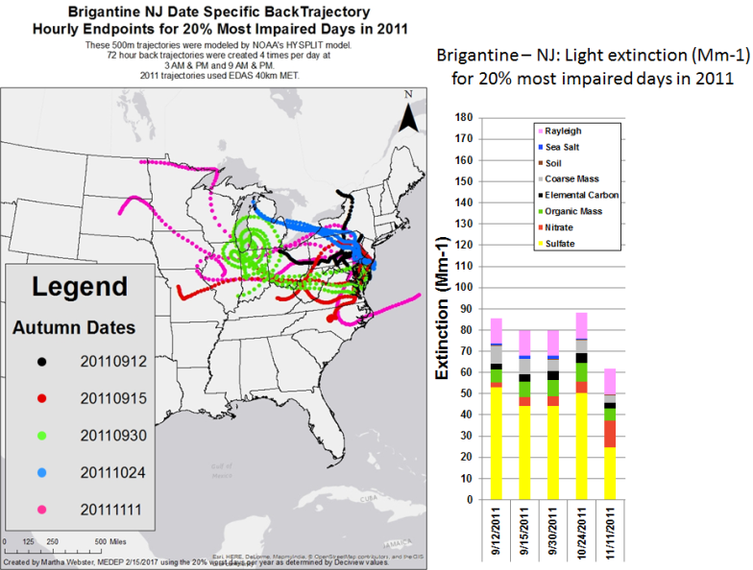
Figure 40: Trajectory analyses of Brigantine Wilderness most impaired days during 2015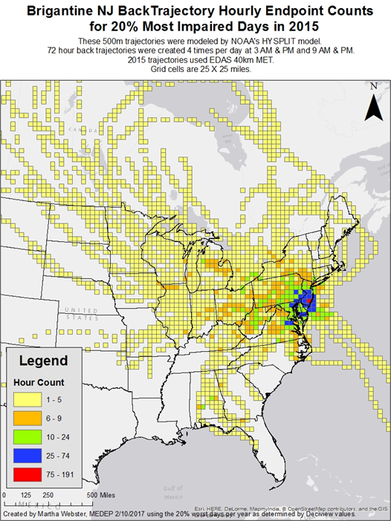
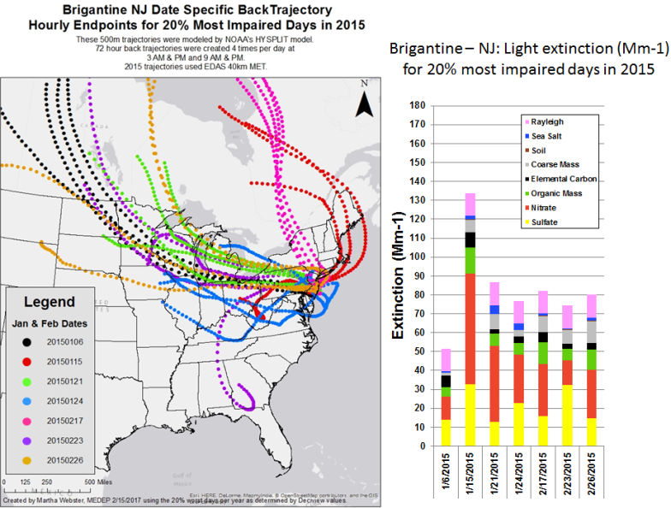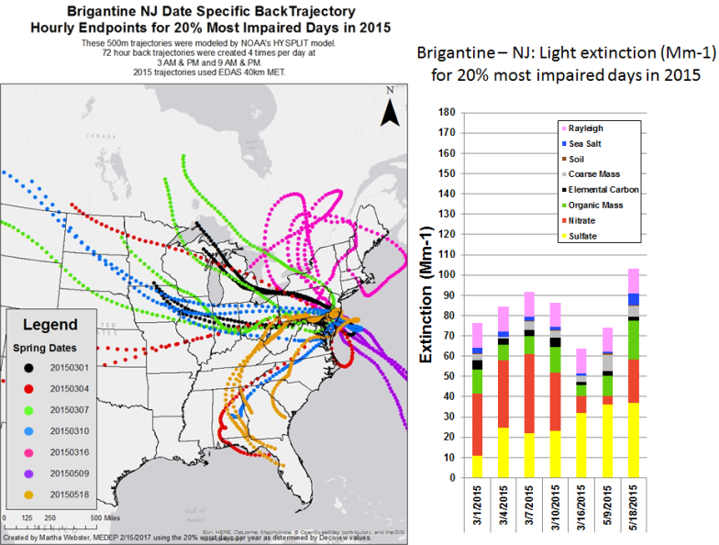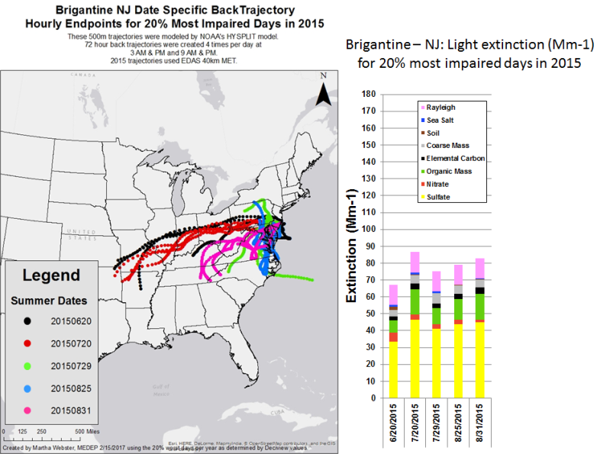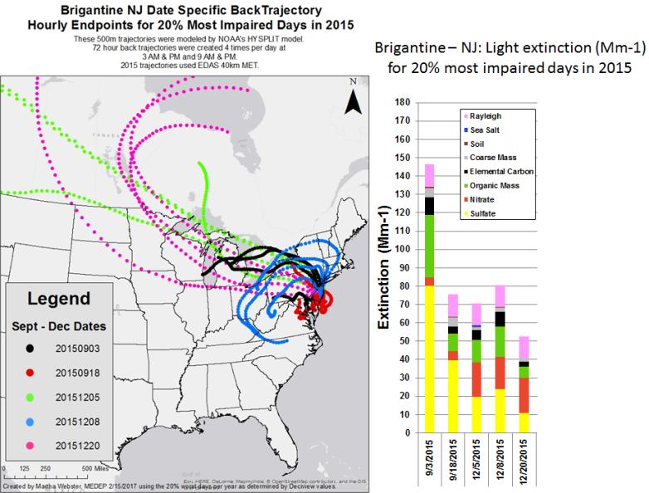

4.1.6 Shenandoah National Park

CALPUFF modeling results showed the following states meeting the criteria contributing to Shenandoah National Park regional haze impacts:

- MANE-VU Northeast states
  - Maryland - 7 EGUs and 2 Industrial Sources
  - New Jersey 1 EGU
  - New York - 1 EGUs
  - Pennsylvania - 11 EGUs and 2 Industrial Sources
- LADCO Midwest states
  - Illinois - 1 EGU and 1 Industrial Source
  - Indiana - 13 EGUs and 1 Industrial Source
  - Michigan - 11 EGUs and 1 Industrial Source
  - Ohio - 10 EGUs and 2 Industrial Sources
- SESARM Southeast states
  - Alabama – 1 EGU
  - Georgia - 3 EGUs
  - Kentucky - 5 EGUs
  - North Carolina – 2 EGUs and 1 Industrial Source
  - Tennessee - 1 EGU and 1 Industrial Source
  - Virginia - 2 EGUs and 1 Industrial Source
  - West Virginia - 6 EGUs and 1 Industrial Source
- CENRAP Central states
  - Iowa – 2 EGUs
  - Texas – 2 EGUs

Trajectory plots for the 2002 (Figure 41), 2011 (Figure 42) and 2015 (Figure 43) 20% most impaired visibility days show trajectories from all the states listed above. From the MANE-VU region, during 2011 and 2015 the strongest signal was from Western Pennsylvania with a few trajectories showing impacts from other Mid-Atlantic MANE-VU states and New York during 2015.

Figure 41: Trajectory analyses of Shenandoah National Park most impaired days during 2002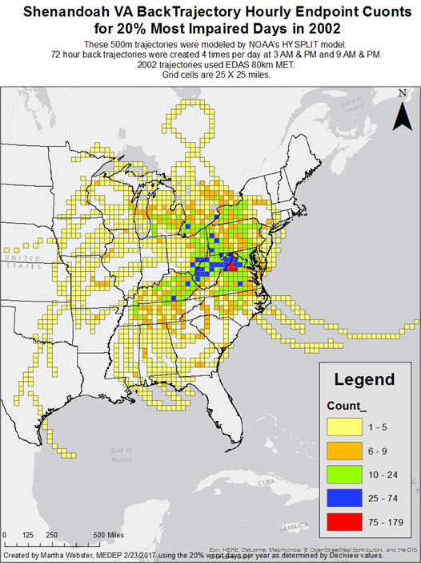
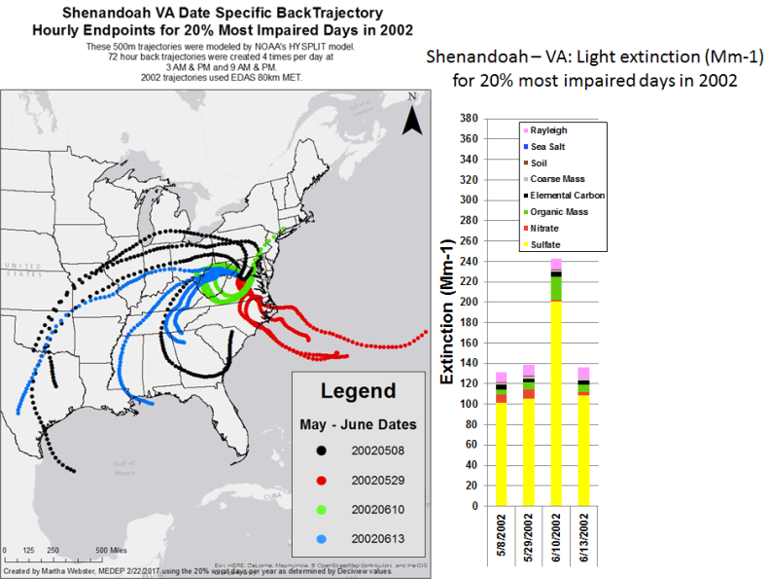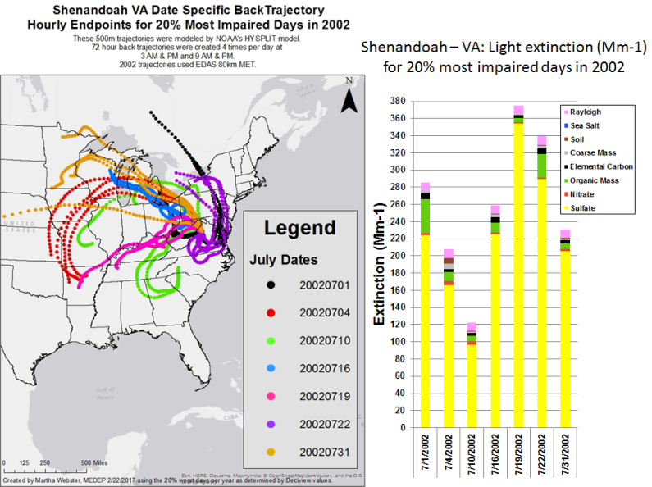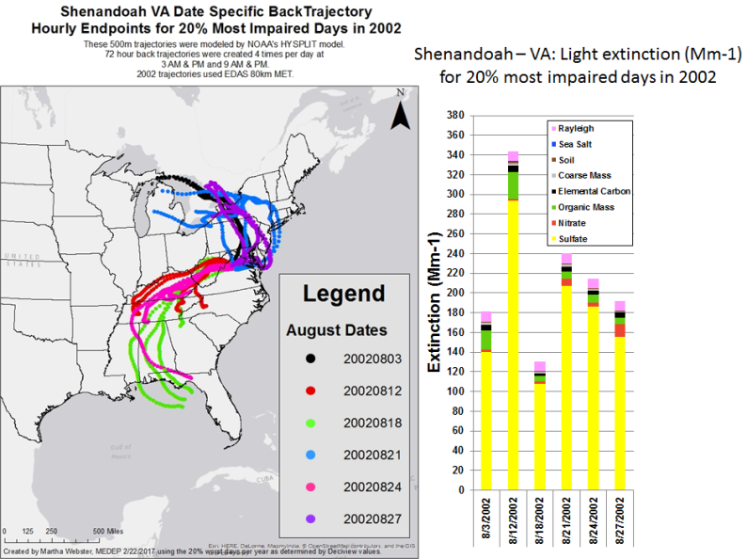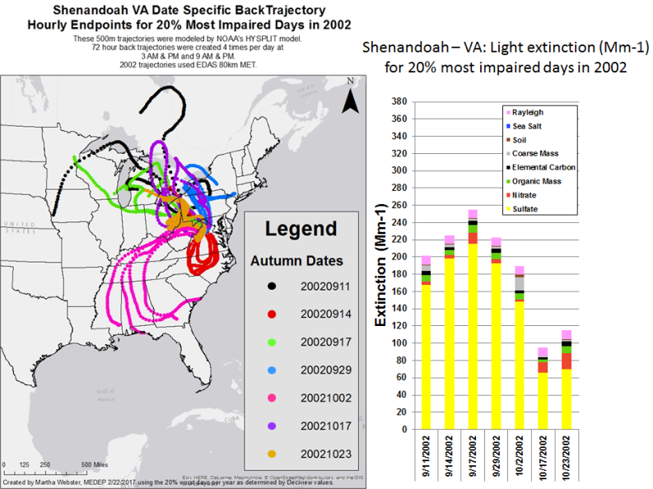
Figure 42: Trajectory analyses of Shenandoah National Park most impaired days during 2011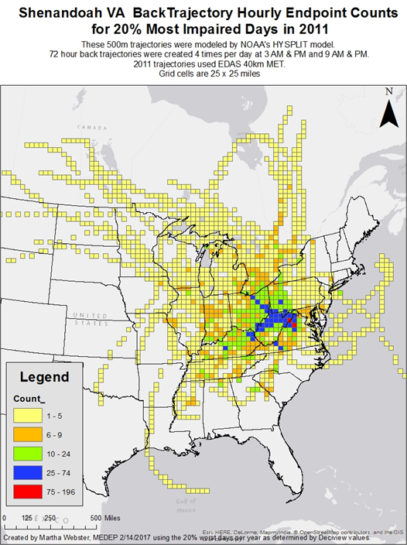
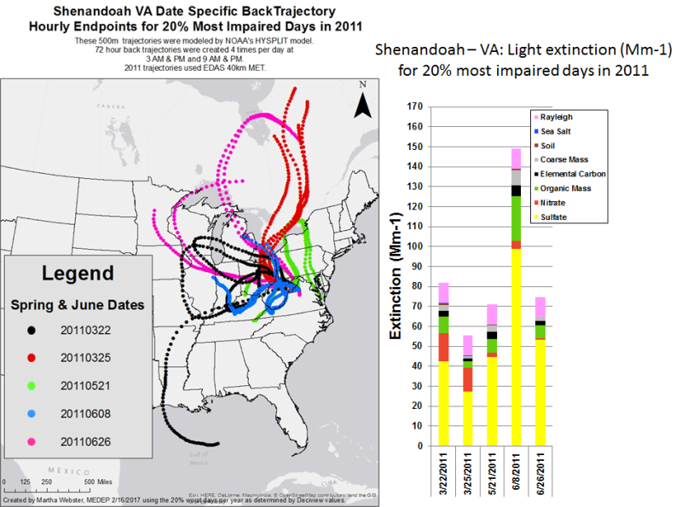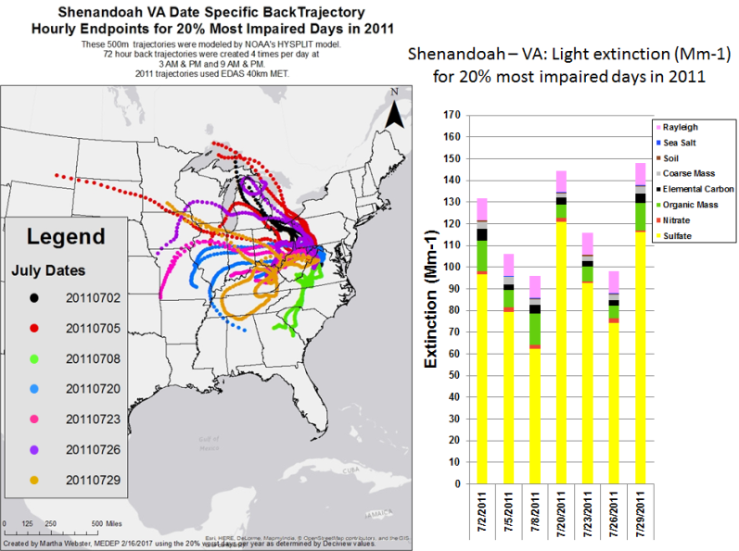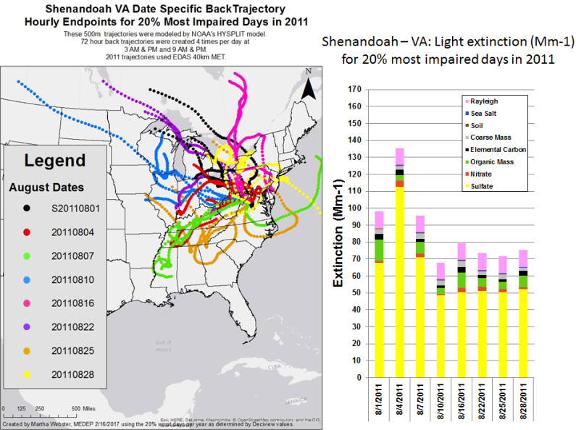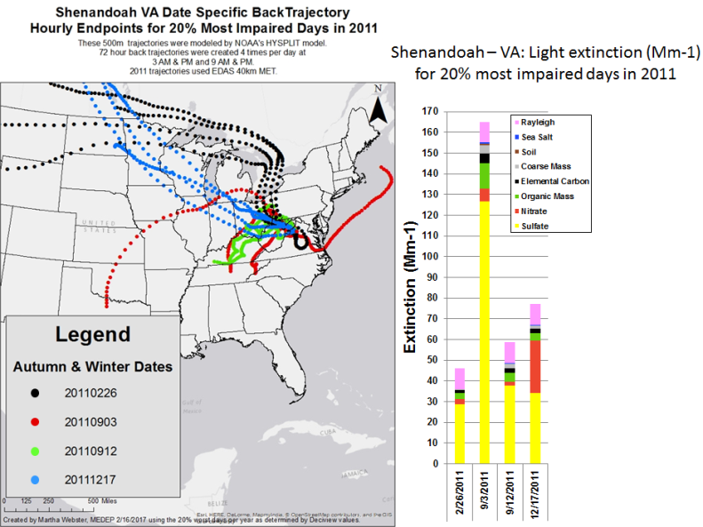
Figure 43: Trajectory analyses of Shenandoah National Park most impaired days during 2015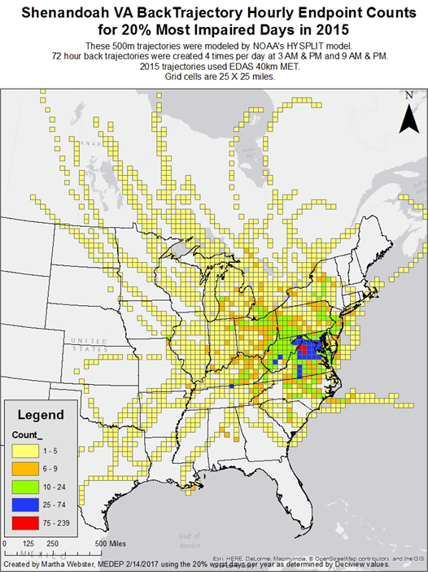
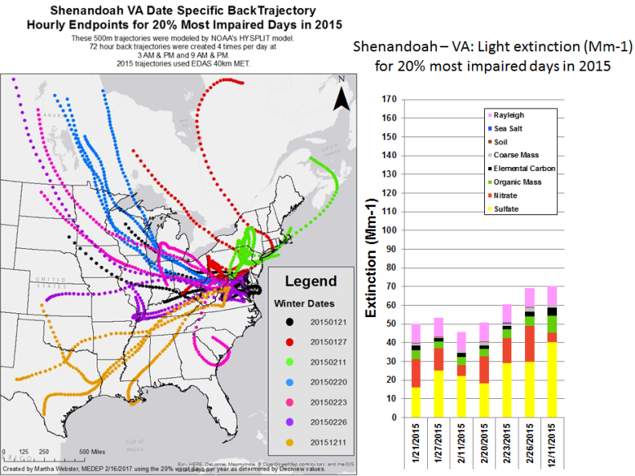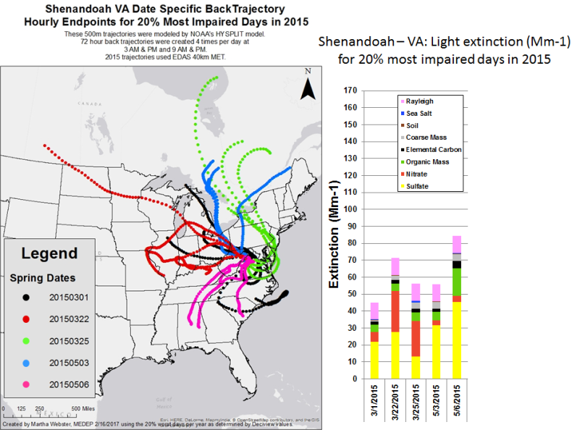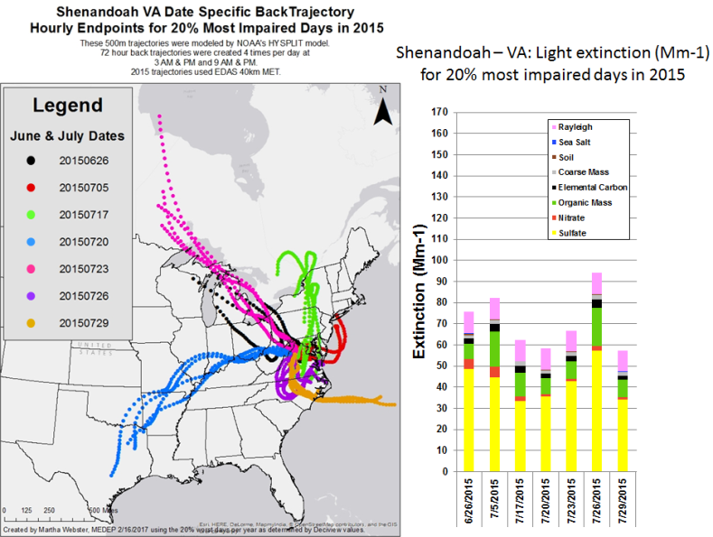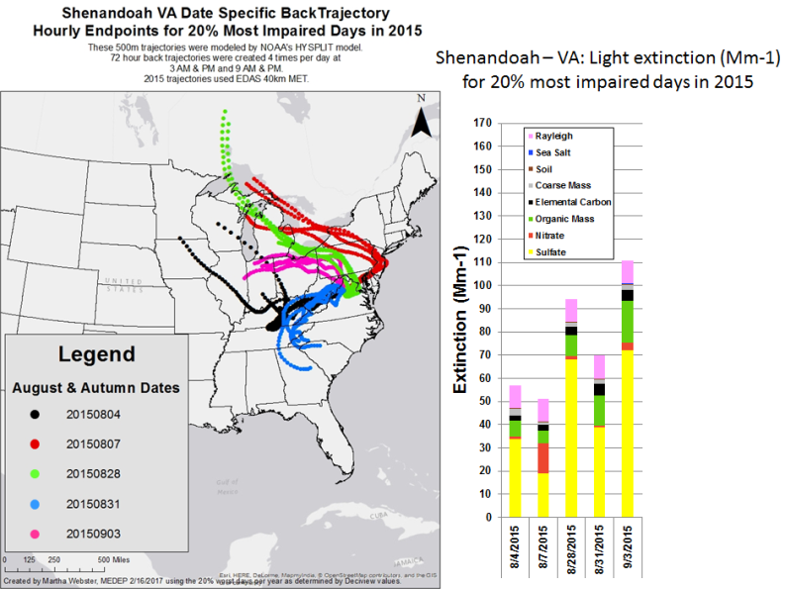

4.1.7 Dolly Sods Wilderness Area

CALPUFF modeling results showed the following states meeting the criteria contributing to Dolly Sods Wilderness regional haze impacts:

- MANE-VU Northeast states
  - Maryland - 6 EGUs and 1 Industrial Source
  - New York - 1 EGU
  - Pennsylvania - 11 EGUs and 2 Industrial Sources
- LADCO Midwest states
  - Illinois - 1 EGU and 1 Industrial Source
  - Indiana - 13 EGUs and 1 Industrial Source
  - Michigan - 11 EGUs and 1 Industrial Source
  - Ohio - 11 EGUs and 2 Industrial Sources
- SESARM Southeast states
  - Alabama – 1 EGU
  - Georgia - 3 EGUs
  - Kentucky - 5 EGUs
  - North Carolina – 2 EGUs and 1 Industrial Source
  - Tennessee - 1 EGU and 1 Industrial Source
  - Virginia - 2 EGUs and 2 Industrial Sources
  - West Virginia - 6 EGUs and 1 Industrial Source
- CENRAP Central states
  - Texas – 2 EGUs

Trajectory plots for the 2002 (Figure 44), 2011 (Figure 45) and 2015 (Figure 46) 20% most impaired visibility days show trajectories from all the states listed above. From the MANE-VU region, during 2011 and 2015 the strongest signal was from Western Pennsylvania with a few trajectories showing impacts from other Mid-Atlantic MANE-VU states and New York.

Figure 44: Trajectory analyses of Dolly Sods Wilderness most impaired days during 2002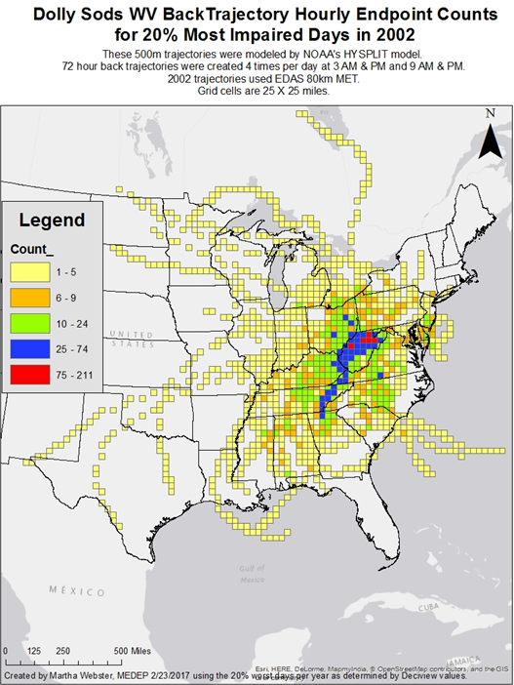
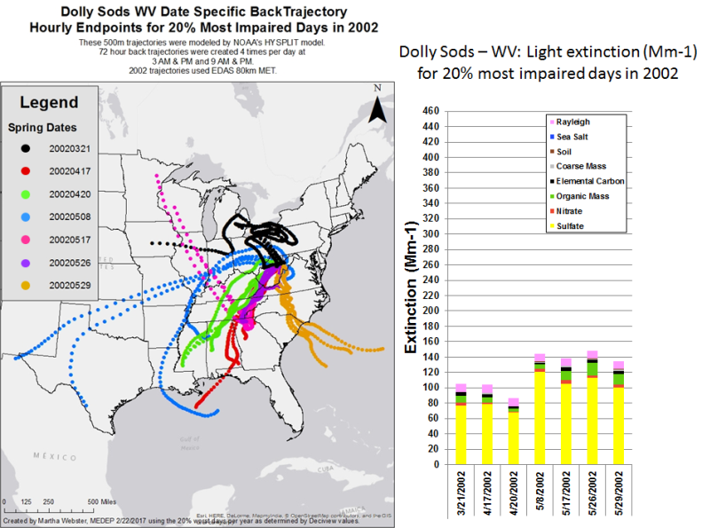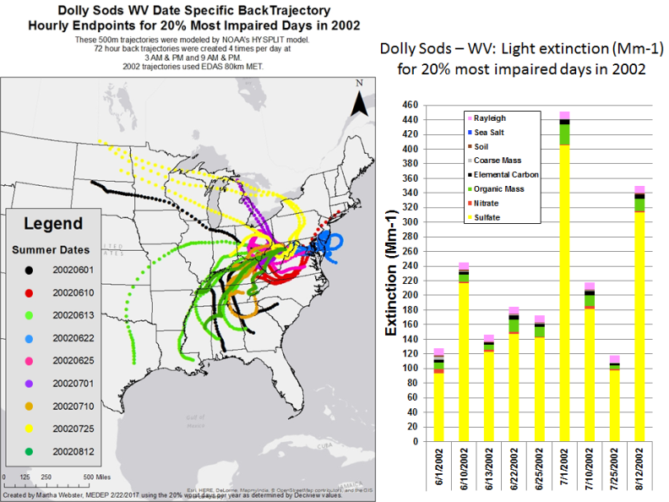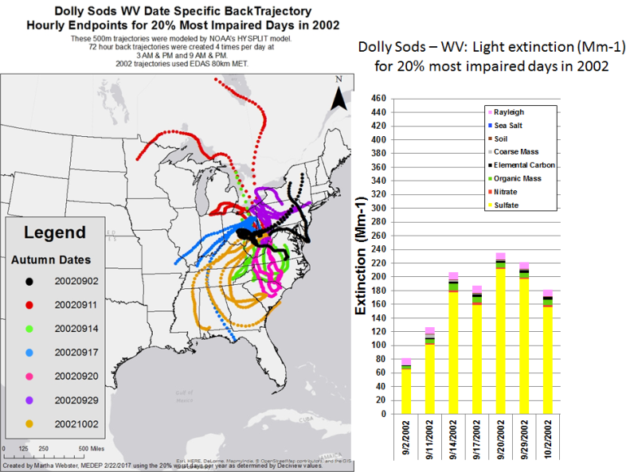
Figure 45: Trajectory analyses of Dolly Sods Wilderness most impaired days during 2011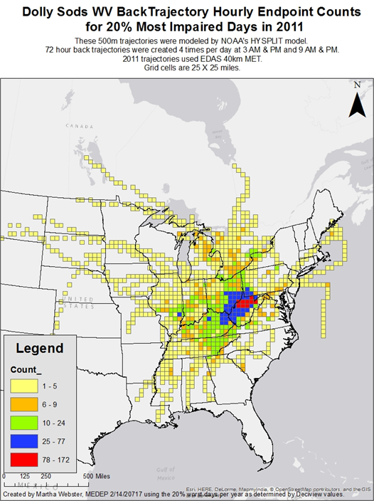
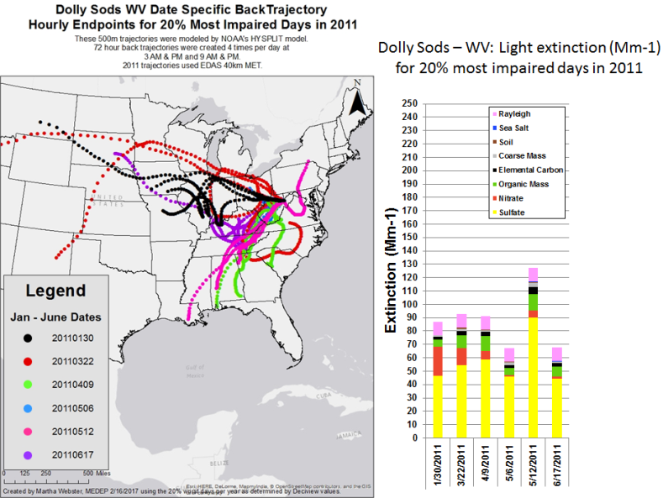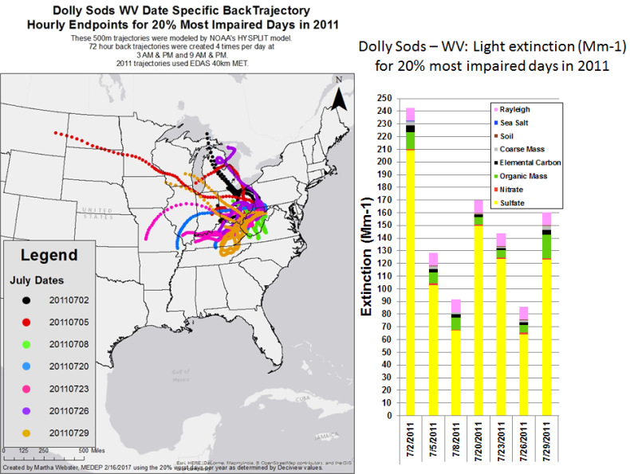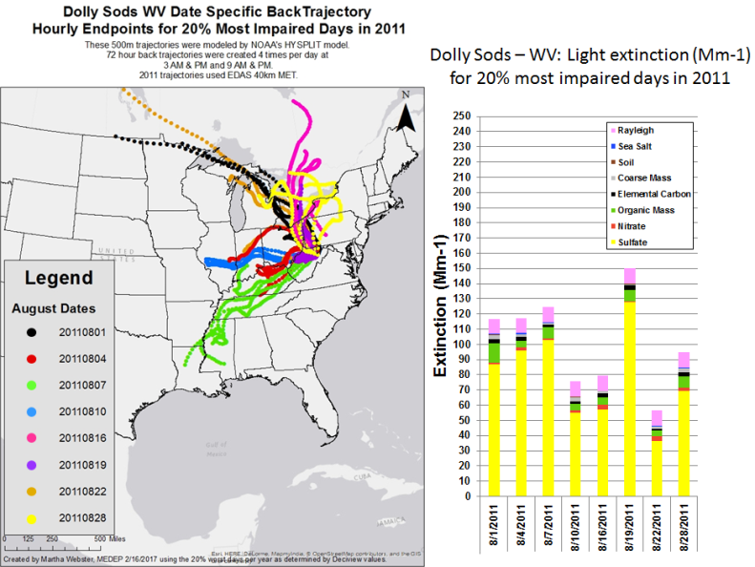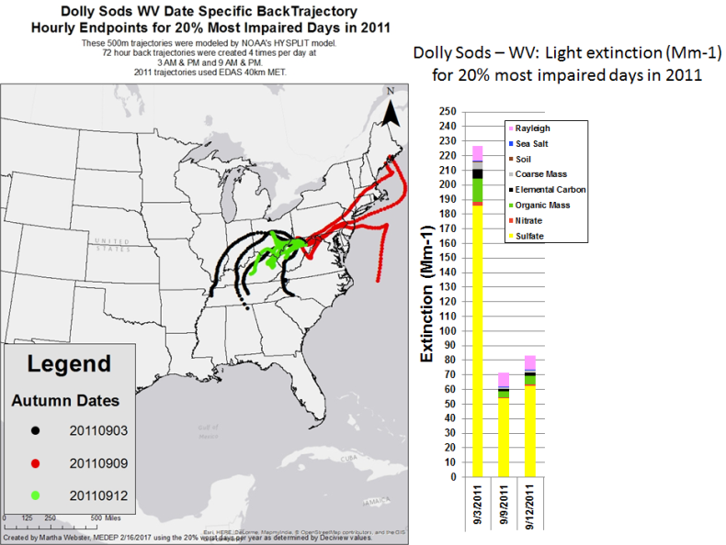
Figure 46: Trajectory analyses of Dolly Sods Wilderness most impaired days during 2015 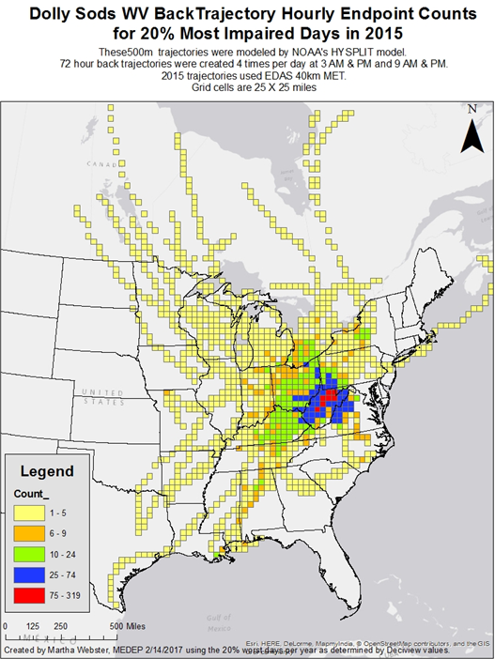
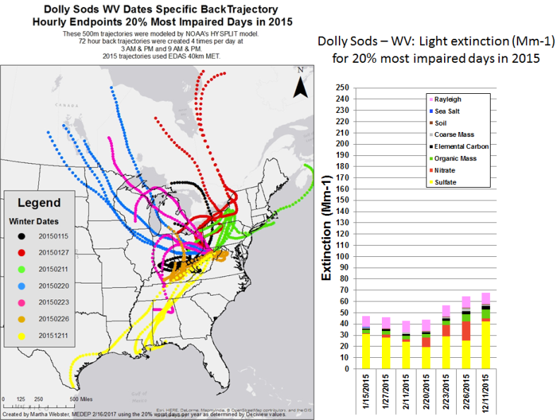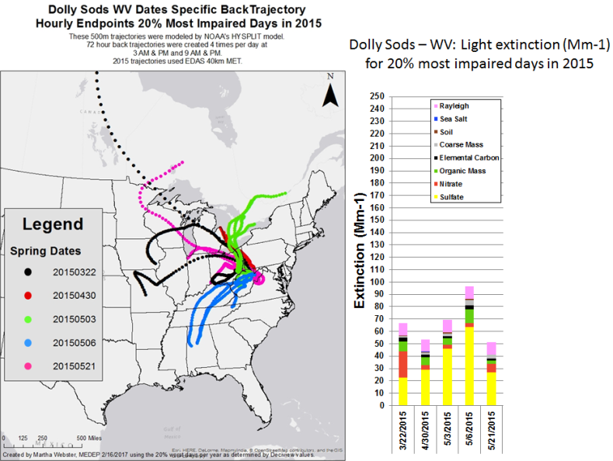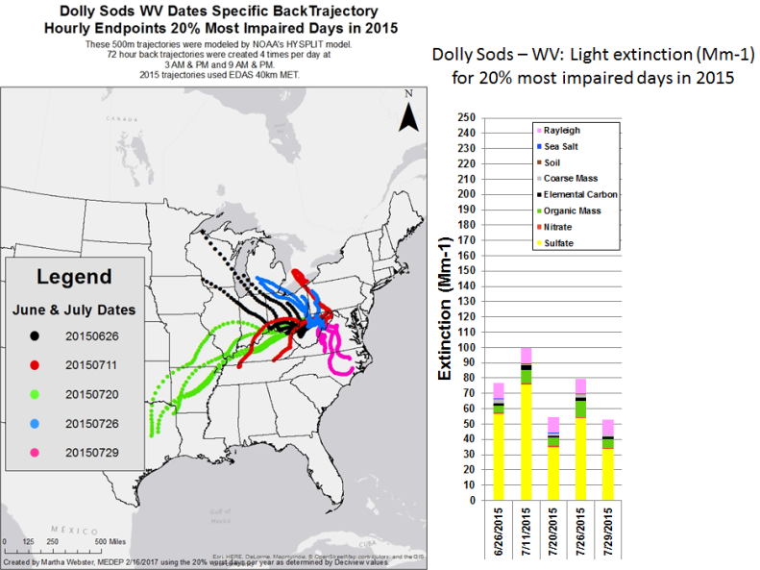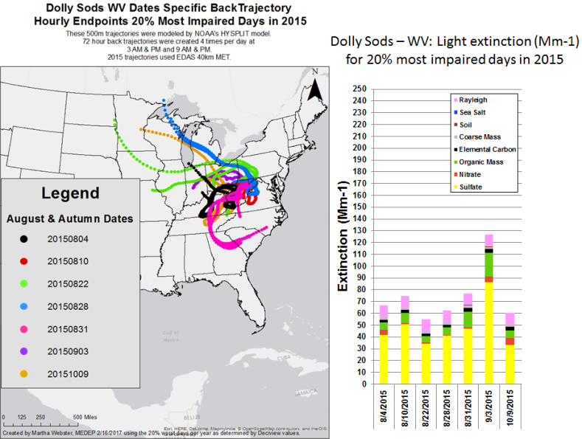

4.1.8 James River Face Wilderness Area

CALPUFF modeling results showed the following states meeting the criteria contributing to James River Face Wilderness regional haze impacts:

- MANE-VU Northeast states
  - Maryland - 5 EGUs and 2 Industrial Sources
  - Pennsylvania - 11 EGUs and 1 Industrial Source
- LADCO Midwest states
  - Illinois - 1 EGU and 1 Industrial Source
  - Indiana - 11 EGUs and 1 Industrial Source
  - Michigan - 8 EGUs
  - Ohio - 10 EGUs and 1 Industrial Source
- SESARM Southeast states
  - Alabama – 1 EGU
  - Georgia - 3 EGUs
  - Kentucky - 5 EGUs
  - North Carolina – 2 EGUs and 2 Industrial Sources
  - Tennessee - 1 EGU and 1 Industrial Source
  - Virginia - 2 EGUs and 3 Industrial Sources
  - West Virginia - 6 EGUs and 1 Industrial Source
- CENRAP Central states
  - Iowa – 1 EGU
  - Oklahoma 1 EGU
  - Texas – 2 EGUs

Trajectory plots for 2002 (Figure 47), 2011 (Figure 48) and 2015 (Figure 49) most impaired visibility days show strong trajectory patterns from Pennsylvania. From the MANE-VU region, during 2011 and 2015 the strongest signal was from Western Pennsylvania with a few trajectories showing impacts from other Mid-Atlantic MANE-VU states and New York.

Figure 47: Trajectory analyses of James River Face Wilderness most impaired days during 2002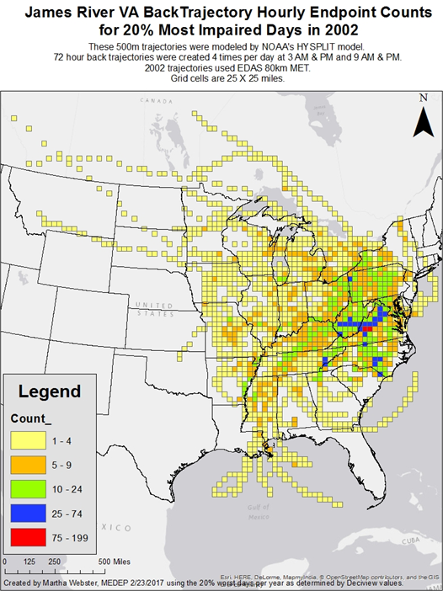
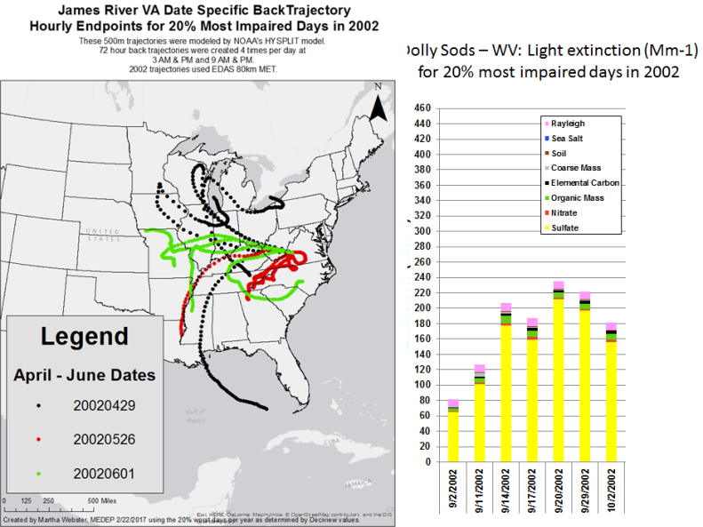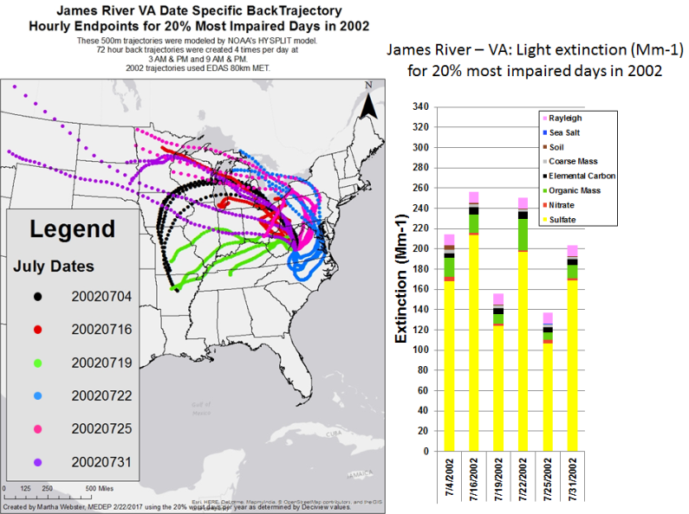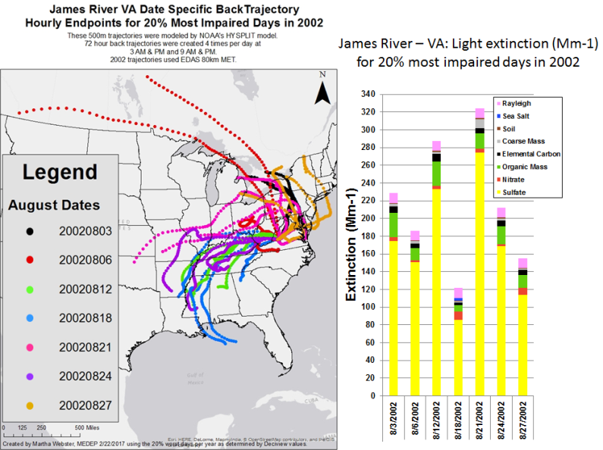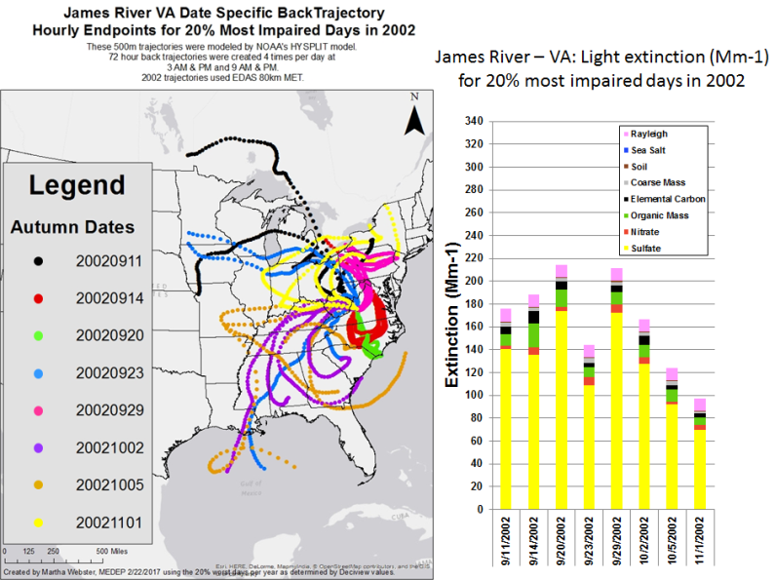
Figure 48: Trajectory analyses of James River Face Wilderness most impaired days during 2011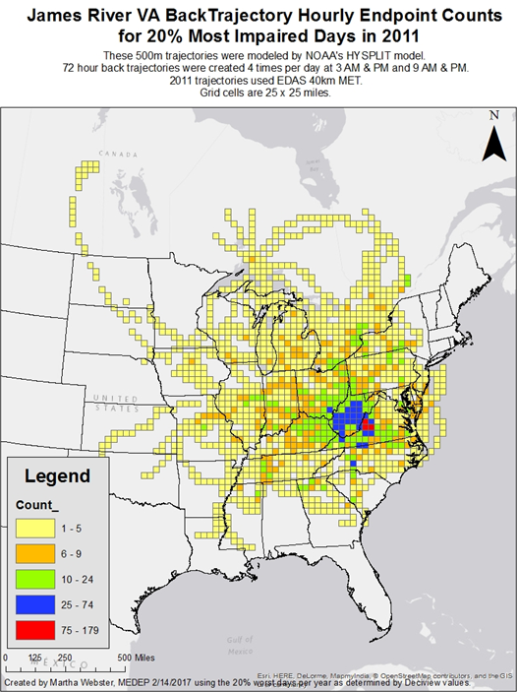
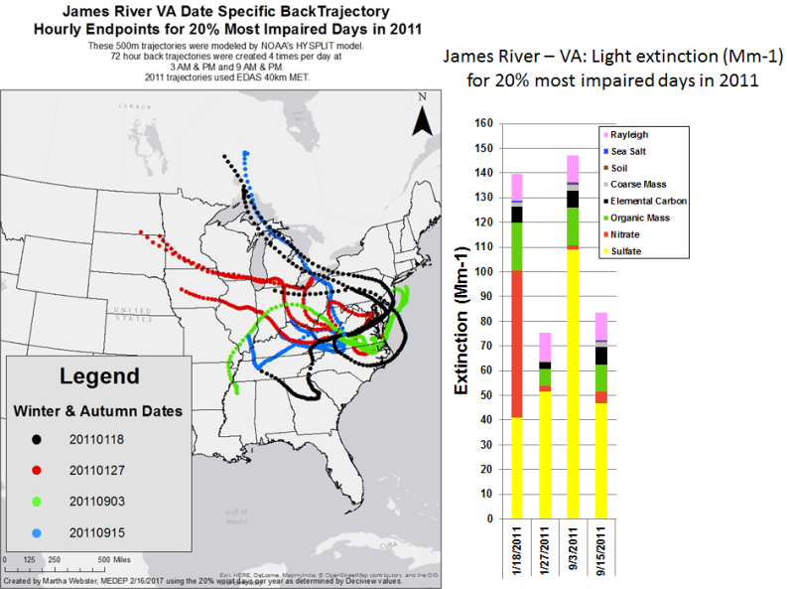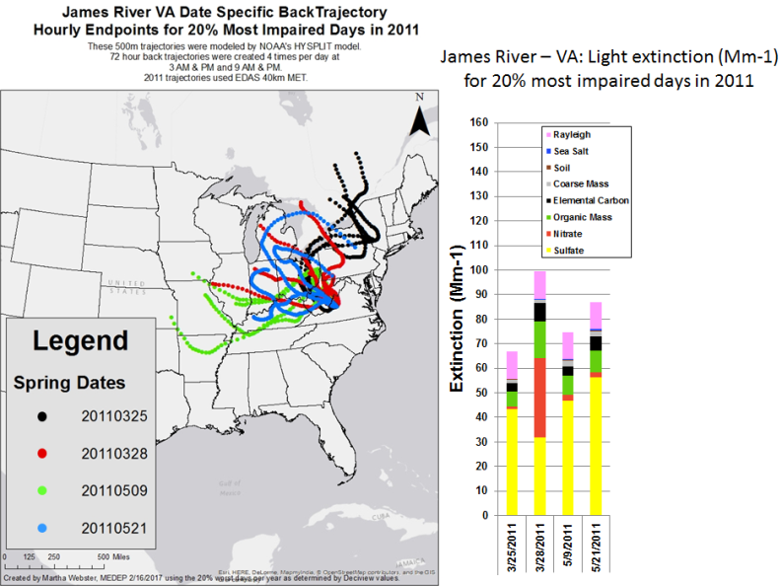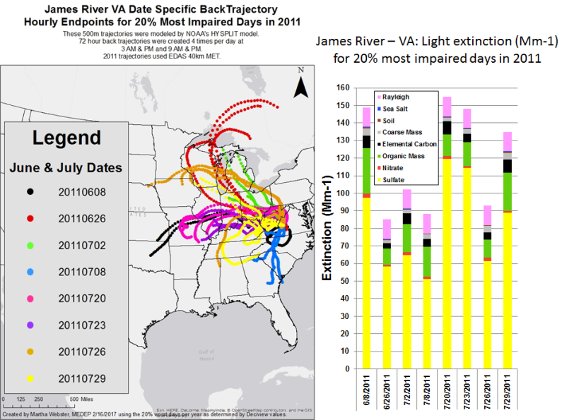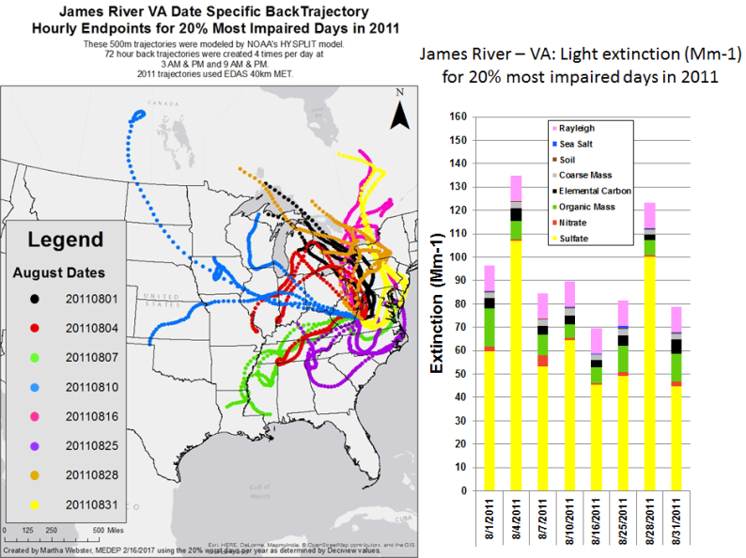
Figure 49: Trajectory analyses of James River Face Wilderness most impaired days during 2015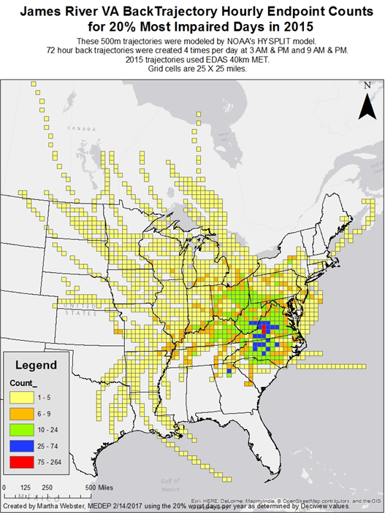
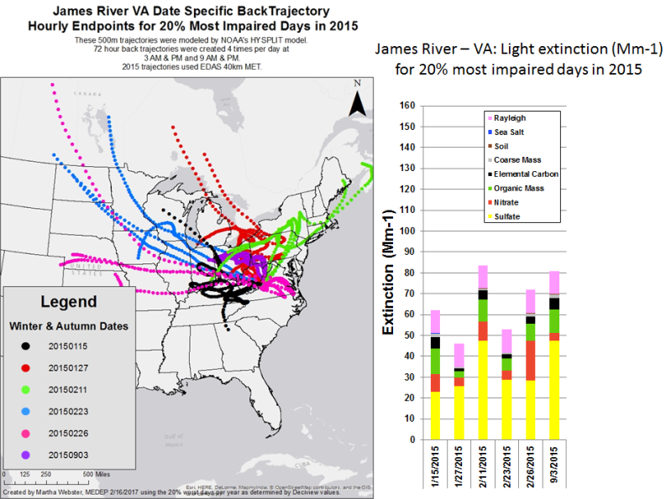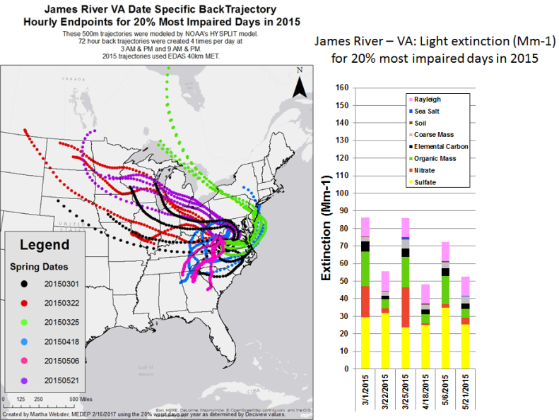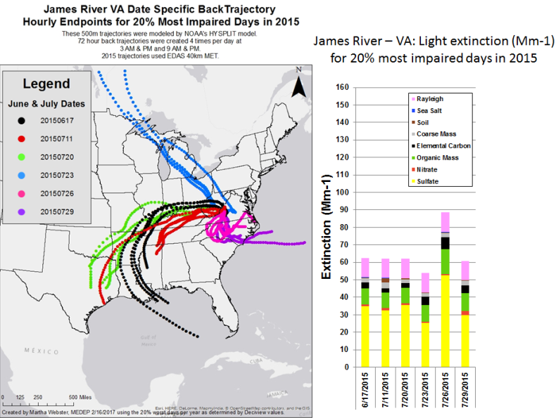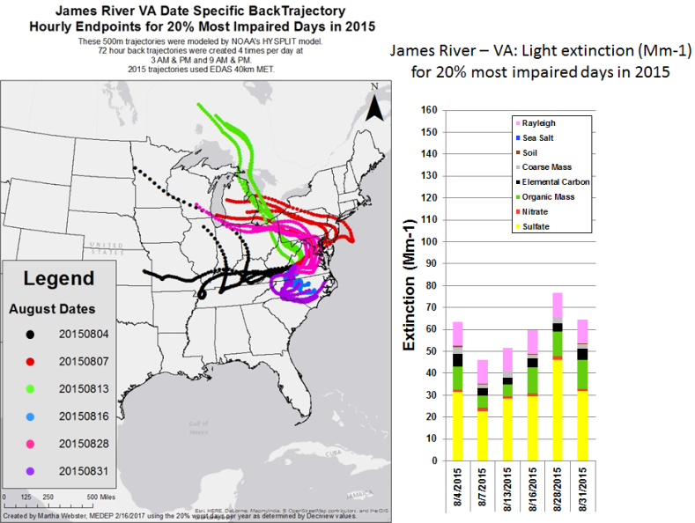

5.0 Summary

As noted in the MANE-VU CALPUFF analysis report, results provided in this report are also not intended to provide policy recommendations. Trajectory analyses results in this report are to give states a general understanding of transport patterns during the most impaired visibility days for each Class I area. It is also anticipated that results of all MANE-VU contribution analyses and four-factor analyses will subsequently be considered for potential policy development.

Observations of results from the speciation analyses include:

- For all Class I areas, the light extinction trend shows a significant decrease from the 2000-04 base period to the 2011-15 current 5-year period.
- The light extinction percentage decrease from the base period (2000-04) to the current 5-year period (2011-15) from sulfates was 17-28% for all Class I areas, however sulfates continues to contribute to regional haze more than other principle components.
- The light extinction percentage increase from the base period (2000-04) to the current 5-year period (2011-15) from nitrates was 5% or more at Lye Brook Wilderness, Brigantine Wilderness, Shenandoah National Park, and James River Face Wilderness Class I sites.
- Nitrate light extinction contribution is largest during the late fall to early spring days.
- Organic mass carbon, sea salt, coarse mass, light absorbing carbon, and soil contribution changes from the base period were all less than 5% at all Class I sites.
- The resulting light extinction percentage decrease from the base period (2000-04) to the current 5-year period (2011-15) from Rayleigh scattering was 9-13% for northern Class I areas and 6-9% for Brigantine Wilderness and other Class I areas in Virginia and West Virginia.

Observations of results from the trajectory analyses include:

- For northern New England Class I areas there were strong transport signals from Canadian sources (forest fire smoke and emissions from high population areas in southern Canada).
- For all MANE-VU Class I areas in 2011 and 2015 there were strong transport signals from LADCO and northern SESARM states.
- In general, the trajectory analyses confirm contribution results from the MANE-VU CALPUFF modeling report.
- For Virginia and West Virginia Class I areas there were strong transport pattern from MANE-VU Mid-Atlantic states with the strongest signal from western Pennsylvania.

References
Draxler, R and Hess, GD 1997, Description of the HYSPLIT 4 Modeling System, accessed from <http://www.arl.noaa.gov/documents/reports/arl-224.pdf>.
‘Federal Land Manager Environmental Database (FED)’, accessed from <http://views.cira.colostate.edu/fed/>.
Mid-Atlantic Northeast Visibility Union 2017, 2016 MANE-VU Source Contribution Modeling Report.
NESCAUM 2006, Contributions to Regional Haze in the Northeast and Mid-Atlantic United States, Boston, MA, accessed from <http://www.nescaum.org/documents/contributions-to-regional-haze-in-the-northeast-and-mid-atlantic--united-states/mane-vu_haze_contribution_asessment--2006-0831.pdf/>.
US EPA 2016, ‘Draft Guidance on Progress Tracking Metrics, Long-term Strategies, Reasonable Progress Goals and Other Requirements for Regional Haze State Implementation Plans for the Second Implementation Period’.
US EPA 2016, Technical Support Document (TSD) Revised Recommendations for Visibility Progress Tracking Metrics for the Regional Haze Program, Research Triangle Park, NC.

